SEISMIC IMAGING OF MEGATHRUST FAULT PROPERTIES AND FOREARC STRUCTURE ALONG AND ACROSS THE MIDDLE AMERICA SUBDUCTION ZONE, OFFSHORE MEXICO

By Grace A. Ward
A Thesis
Submitted in Partial Fulfillment
of the Requirements for the Degree of
Master of Science
in Geology

Northern Arizona University
June 2026

Approved:
Donna Shillington, Ph.D., Chair
Jim Gaherty, Ph.D.
Christine Regalla, Ph.D.
Anne Bécel, Ph.D.

ABSTRACT
SEISMIC IMAGING OF MEGATHRUST FAULT PROPERTIES AND FOREARC STRUCTURE ALONG AND ACROSS THE MIDDLE AMERICA SUBDUCTION ZONE, OFFSHORE MEXICO
GRACE WARD
Slow slip events (SSEs) are an important but poorly understood type of slip at subduction zones. It remains unclear what physical conditions promote the occurrence of slow slip versus earthquake slip on plate boundary faults. The Guerrero segment of the Mexico Subduction Zone (MSZ) has experienced both deep and shallow slow slip events but has not hosted a large megathrust earthquake in ~115 years. In contrast, adjacent segments regularly rupture in Mw>7 earthquakes. To investigate the architecture and physical properties of the Mexico subduction zone across areas that experience different slip behavior, we analyzed multi-channel seismic (MCS) reflection data from the 2022 ¡Me Gusta! expedition. Two seismic profiles were examined: a trench-perpendicular profile crossing the subduction zone SE of the Guerrero Gap near Acapulco (Line 3) and a trench-parallel forearc profile extending across the Guerrero Seismic Gap (GSG) and adjacent segments (Line 4). Seismic reflection imaging reveals that the shallow plate boundary offshore Acapulco is relatively smooth and laterally continuous despite the presence of bending faults and seamounts on the incoming Cocos Plate. Trench sediments are thin (~200 m) and appear to be largely accreted into a small frontal prism rather than subducted. A highly reflective plate interface extends ~18 km landward of the trench and to depths of ~8 km before becoming less reflective at greater depths. Reflection coefficient estimates derived from pre-stack shot gathers range from ~0.11 to 0.25, which can be explained by the impedance contrast between the accretionary prism and oceanic crust. Along-strike variations observed on Line 4 show enhanced reflectivity beneath the northwestern portion of the GSG, coinciding with regions previously interpreted to host SSEs associated with thicker gabbroic crust and elevated pore-fluid pressures. This study reveals along-strike and downdip variations in plate boundary reflectivity that sometimes coincide with changes in megathrust slip behavior along the MSZ, but the correlation is not consistent, suggesting that additional methods are needed to examine controls on slip behavior.

ACKNOWLEDGMENTS
I would like to express my sincere gratitude to my advisor, Donna Shillington, for her guidance, patience and continued support throughout this project and my graduate studies. Her mentorship, insight, and dedication to scientific research have greatly shaped my development as a researcher and scientist. I am especially grateful for the time and effort she invested in me throughout this journey.
I would also like to thank my committee members, Jim Gaherty, Christine Regalla, and Anne Bécel, for their valuable feedback, thoughtful discussions, and support throughout the completion of this thesis. Their guidance and expertise strengthened both this work and my growth as a researcher.
To my family, thank you for your endless encouragement and support throughout every stage of my academic career. Your belief in me gave me the strength and motivation to continue through the challenges of graduate school, and I would not be where I am today without you.
I am deeply grateful to the mentors, professors, colleagues, and friends who supported me throughout both my undergraduate and graduate education. Your encouragement, advice, and belief in my abilities helped shape my path for my career and made this achievement possible. I am thankful for every opportunity, lesson, and moment of support along the way.
Finally, I would like to acknowledge everyone who contributed to the research, field work, discussions, and collaborative environment that made this thesis possible. This accomplishment reflects not only my own efforts, but also the support and generosity of the many people who helped me along the way.

LIST OF FIGURES
Figure 1. Tectonic setting of the Mexico Subduction Zone and Guerrero Seismic Gap..4
Figure 2. Overview map of ¡Me Gusta! Seismic reflection and OBS profiles offshore Mexico……………………………………………………………………………………………4
Figure 3. Seismic reflection data processing workflow used in this study………………11
Figure 4. Pre-stack depth migrated seismic reflection profiles of Line 3 and 4………...17
Figure 5. Zoomed seismic images of the trench and accretionary prism along Line 3..18
Figure 6. Example bending fault measurements…………………………………………..18
Figure 7. Zoomed view of bending faults and vertical offset measurements…………...19
Figure 8. Pre-stack shot gather used for reflection analysis..……………………………20
Figure 9. Location of shot gathers analyzed on Line 3……………………………………21
Figure 10. Reflection coefficient comparison for seafloor and megathrust interfaces of Line 3……………………………………………………………………………………………21
Figure 11. Thermal model comparison with Line 3 megathrust reflectivity……………..26
Figure 12. Theoretical reflection coefficients for prism and oceanic crust impedance values of Line 3………………………………………………………………………………...28
Figure 13. Along-strike reflectivity variations within the Guerrero Seismic Gap………..32

TABLE OF CONTENTS
ABSTRACT 2
ACKNOWLEDGMENTS 4
LIST OF FIGURES 5
1.0 Introduction 7
2.0 Tectonic Background of the Mexico Subduction Zone 11
3.0 Methods 15
3.1 Seismic Data Acquisition 15
3.2 Seismic Reflection Data Processing 17
3.3 Reflection Coefficient Estimation 19
4.0 Results 21
4.1 The Incoming Cocos Plate 21
4.2 Trench & Plate Interface 22
4.3 Accretionary Prism and Overriding North America Plate 27
5.0 Discussion 28
5.1 Influence of the Incoming Plate on Megathrust Properties 28
5.2 Downdip and Along-strike Variations in Megathrust Properties 30
5.3 Impacts on Slip Behavior 38
6.0 Conclusion 41
REFERENCES 43

1.0 Introduction
Subduction zone megathrusts produce a spectrum of slip behaviors, from fast, high-magnitude earthquakes to slow, aseismic events such as slow slip events (SSEs) and tremor. Megathrust earthquakes occur when stress is built up between a subducting and overlying plate and is suddenly released, producing intense ground motion and potentially triggering tsunami. SSEs, in contrast, release stress more gradually over days to months (Obara & Kato, 2016). Though less damaging on their own, SSEs are key to understanding the mechanics of subduction zones and how stress evolves throughout the broader earthquake cycle (Scholz, 2019; Beroza & Ide, 2011; Wallace, 2020).
SSEs have been observed in subduction zones worldwide, including Cascadia (Saux et al., 2022), Nankai, Japan, (Nishikawa et al., 2023), New Zealand (Truttmann et al., 2024), Aleutians (Okada & Nishimura, 2023), Costa Rica (Perry et al., 2023), and Mexico (Cruz-Atienza et al., 2021; 2025). In Cascadia, SSEs occur downdip of the locked megathrust, transitioning into tremor zones. At Nankai, SSEs are observed updip near the trench, while in Japan, SSEs have occurred in the proximity of large earthquakes (Obara & Kato, 2016; Nishikawa et al., 2023). In Mexico, slow-slip events occur updip, downdip and in the same depth range as earthquake slip (Radiguet et al., 2016; Cruz-Atienza et al., 2025). The spatial relationship between SSEs and megathrust earthquakes has led to renewed interest in whether SSEs play a role in modulating or triggering seismic slip. For example, the 2011 Mw 9.1 Tohoku-Oki earthquake in Japan was preceded by SSE activity in the same area (Uchida & Bürgmann, 2021). In northern Chile, SSEs were detected near the hypocenter of the 2014 Mw 8.1 Iquique earthquake (Ruiz et al., 2014). Similarly, the 2014 Mw 7.3 Papanoa earthquake and the 2021 Mw 7.0 earthquake in Mexico were preceded by a SSE (Radiguet et al., 2016; Gualandi et al., 2017; Cruz-Atienza et al., 2025). These observations raise questions about the relationship between slow and fast slip behavior: Do SSEs relieve stress and delay megathrust earthquakes, or do they transfer stress to adjacent locked areas, increasing earthquake potential? (Dixon et al., 2014; Schwartz & Rokosky, 2007; Graham et al., 2017; Dascher-Cousineau & Bürgmann, 2024).
Several physical factors have been proposed to control the style and location of slip along subduction zones. SSEs are often associated with elevated pore-fluid pressures, which reduce effective normal stress and promote stable sliding (Saffer & Wallace, 2015; Saffer & Tobin, 2011). For example, in Cascadia, radial receiver functions reveal the deep megathrust is a fluid-rich, low-permeability boundary and capable of sustaining SSEs and tremor (Audet et al., 2009). Structural heterogeneity in the incoming plate—such as variations in lithology, faulting, topography, and sediment cover—can influence locking, promote slow slip conditions, and limit rupture propagation (Barnes et al., 2020; Tilley et al., 2021; Saffer & Wallace, 2015; Takemura et al., 2025; van Rijsingen et al., 2018). Subduction of seamount chains or fracture zones may locally alter coupling conditions or contribute to aseismic deformation (Wang & Bilek, 2011). Thermal structure, slab geometry, and sediment input also influence the location and characteristics of slow slip (Manea et al., 2004; Currie et al., 2002; Audet et al., 2009; Heuret et al., 2012; Brizzi et al., 2020; Saffer & Wallace, 2015).
Low sediment conditions are thought to promote stronger coupling near the trench and reduce the fluids that incorporate into the subduction system (von Huene & Scholl, 1991; Saffer & Bekins, 2006). Subduction zones with thick incoming sediment (e.g., Cascadia, Nankai) may host both shallow SSEs and large ruptures depending on fluid retention and mechanical properties (Heuret et al., 2012; Brizzi et al., 2020). For example, at Nankai, observations from the NanTroSEIZE drilling project show a strong correlation between pore-fluid pressure, low effective stress, and the occurrence of shallow slow slip (Tobin & Kinoshita, 2006; Bedford et al., 2021).
Improving constraints on the structural and physical controls of SSEs is essential for understanding how slow slip fits into the broader seismic cycle. Understanding how heterogeneity in the plate interface and overriding plate affects fluid migration, coupling, and frictional behavior is critical for assessing seismic hazard. SSEs may also provide early indicators of fault loading and help identify regions capable of producing large megathrust earthquakes (Frank et al., 2016; Obara & Kato, 2016; Jiang et al., 2017).
This study investigates the structural controls on slip behavior in the Guerrero Gap and surrounding segments of the Mexico Subduction Zone (MSZ) (Figs. 1, 2). Using multichannel-seismic (MCS) reflection from the 2022 ¡Me Gusta! Experiment (Bécel et al., 2023), we aim to characterize variations in faulting and sediment input from the incoming plate, plate boundary properties and forearc faulting (Fig. 2). Our research aims to address the following questions: 1) What structural features correlate with the occurrence of slow slip events versus megathrust earthquake ruptures? 2) Do downdip and along-strike variations in plate interface reflectivity correspond to changes in coupling or slip behavior? By integrating geophysical observations to slip behavior, this work contributes to a greater understanding of subduction zone mechanics and the conditions that promote different styles of fault slip.
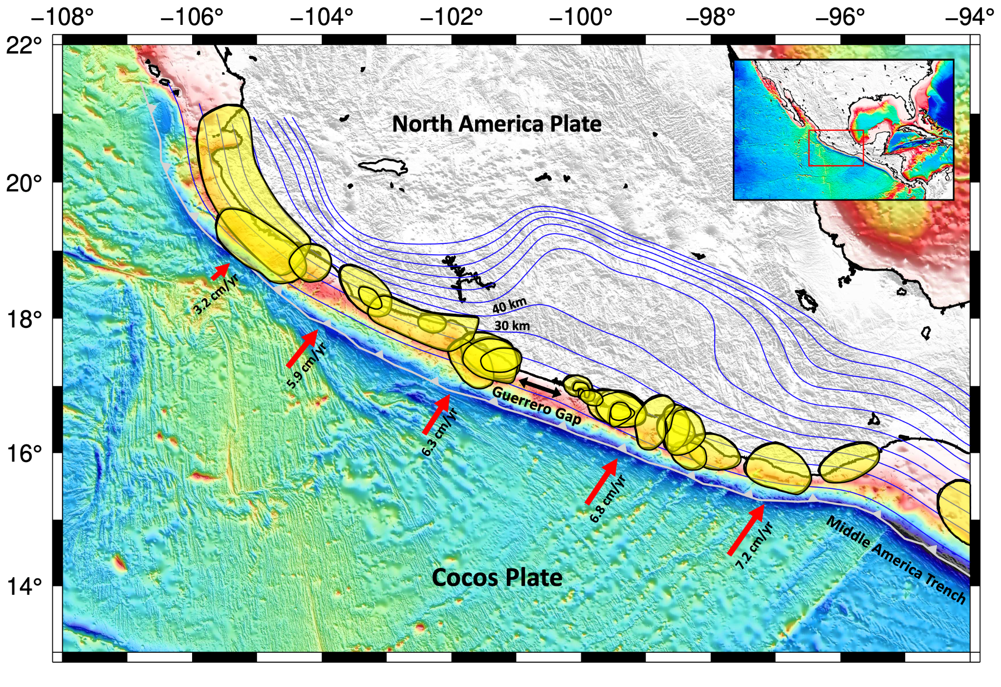
Figure 1. Middle America subduction zone where the Cocos Plate subducts under the North America Plate. Convergence directions in red with their respective rates (DeMets et al., 2010). Earthquake rupture areas shown in yellow (Cruz-Atienza et al., 2018). Guerrero Gap labeled with black arrows. Blue contour lines represent slab depth, intervals of 10 km (Hayes et al., 2018).
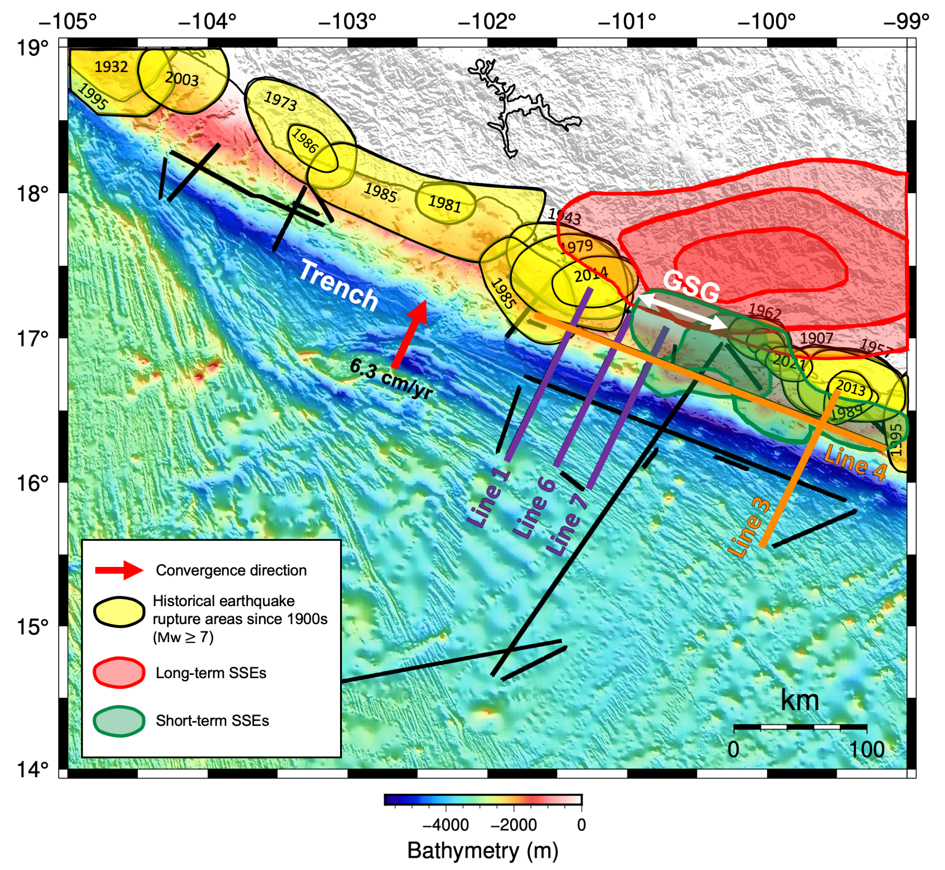
Figure 2. Red arrows show convergence direction (DeMets et al., 1994). Earthquake rupture areas are shown in yellow and dates of earthquakes since 1900 (Cruz-Atienza et al., 2018). Deep, long-term SSEs are labeled in red and shallow, short-term in green (Cruz-Atienza et al., 2025). Guerrero Seismic Gap (GSG) extent is represented with white arrows. Black lines are seismic reflection profiles; Lines 3 and 4 are the focus of this study in orange, and Lines 1, 6, and 7 are labeled in purple (Bécel et al., 2023).

2.0 Tectonic Background of the Mexico Subduction Zone
The Middle American Trench (MAT) marks the boundary where the oceanic Cocos Plate subducts beneath the continental North American Plate along the Mexico Subduction Zone (MSZ). The MSZ has along-strike variations in coupling, seismicity, and forearc morphology (Kostoglodov et al., 2003; Radiguet et al., 2012; Kim et al., 2010). Numerous large (Mw>7) earthquakes have ruptured segments of the MSZ such as Mw 8.0 Colima-Jalisco earthquake (1995) and Mw 8.0 Michoacan earthquake (1985) (Fig. 2), and yet geophysical data has revealed a spectrum of slip behavior ranging from fast megathrust rupture to slow slip and tremor (Brudzinski et al., 2007; Radiguet et al., 2012, 2016; Graham et al., 2017). These variations make the MSZ a valuable region for understanding the physical controls on megathrust behavior. However, the characteristics of the incoming and overriding plates, including plate boundary properties and fluid conditions remain poorly constrained in several segments of the margin.
Within this tectonic setting, the Guerrero Seismic Gap (GSG) has been identified as a segment with high seismic potential. It is a ~200-km-long segment that has not experienced a major megathrust earthquake in over a century (Fig. 1; Cruz-Atienza et al., 2018; Radiguet et al., 2012). Based on historical records, geologic and geodetic evidence, the GSG has the potential to produce an earthquake of Mw >8 (Suárez, 1990; Kostoglodov, 1996; Bekaert et al., 2015), posing a major risk to populations such as Acapulco and even distant areas like Mexico City.
One feature of the GSG is its recurring slow slip events (SSEs). SSEs have been recorded since the first continuous GPS stations were deployed in 1993, primarily in regions of Guerrero and central Oaxaca (Brudzinski et al., 2007; Radiguet et al., 2012; Cruz-Atienza et al., 2021; Correa-Mora et al., 2008), where the GSG has recorded SSEs approximately every four years (Kostoglodov et al., 2003; Radiguet et al., 2016; Graham et al., 2017). These SSEs occur at depths ranging from ~15–40 km and can result in maximum slip amplitudes of ~200 mm—equivalent to Mw 7.5 earthquakes (Radiguet et al., 2012; Graham et al., 2017). SSEs have been interpreted to be influenced from frictional conditions and elevated pore-fluid pressures along the deeper interface (Obara & Kato, 2016; Saffer & Wallace, 2015). Farther southeast, the adjacent Oaxaca region hosts more frequent but smaller SSEs (Brudzinski et al., 2007; Correa-Mora et al., 2008 & 2009; Graham et al., 2014 & 2017; Maury et al., 2018; Husker et al., 2019), highlighting the along-strike variability of aseismic behavior.
Historically, adjacent regions to the GSG have experienced large megathrust earthquakes, such as the 1985 Michoacan earthquake (Mw 8.0) to the northwest (Fig. 2). The GSG, however, has remained seismically quiet in terms of large events since at least 1911 (Ramírez-Herrera et al., 2012; Bekaert et al., 2015; Cruz-Atienza et al., 2018). Events have occurred outside the segment, including the Mw 7.3 Papanoa earthquake in 2014 and the Mw 7.1 Acapulco earthquake in 2021 (Fig. 2). Both the 2014 Papanoa and 2021 Acapulco events, located near the northwestern and southeastern edges of the GSG, respectively, have drawn attention due to their temporal and spatial proximity to a preceding SSE, suggesting possible triggering by aseismic stress changes (Radiguet et al., 2016; Cruz-Atienza et al., 2025). The spatial and temporal proximity of megathrust earthquakes and SSEs in Guerrero implies a possible relationship between the two modes of slip. Several historical ruptures also overlap with our study, including the 2013 Mw 6.2, 1989 Mw 7.0, 1985 Mw 7.6, 1957 Mw 7.6 and 1907 Mw 7.6 earthquake events (Fig. 2). These overlapping rupture zones provide important context for interpreting along-strike variability.
The incoming Cocos Plate characteristics could ultimately influence the slip behavior and the seismic activity in the Guerrero region. The Cocos Plate is relatively young, ranging in age from 11-17 Ma along trench from northwest to southeast (Lonsdale, 1995). Outboard of the GSG, in particular, the subducting plate is approximately 13 Ma (Middle Miocene), converging at a rate 6.4 to 6.7 cm/yr, and is shallowly dipping 15–20° near Acapulco (DeMets 2010, Kim et al. 2010, 2012). Černý et al. (2020) has found that there is evidence of subducted seamounts within the GSG that could potentially create asperities that can nucleate earthquakes up to Mw ~7.5. In addition, trench sediment thickness also varies along strike, with ~500–600 m in western Guerrero, ~300 m in the central segment, and <100 m in the easternmost part (Černý et al., 2020).
Drill sites on both the incoming Cocos Plate and offshore forearc region during DSDP Leg 66, found that the Cocos plate is covered in ~200 m of pelagic and hemipelagic sediments (Moore et al., 1982). Sediments recovered from the forearc slope range in age from Miocene to Pleistocene, indicating that sediment accretion along the Middle American Trench was already active by Early Miocene (23-20 Ma; Moore et al., 1982). At subduction zones, incoming sediments can influence the frictional behavior of the megathrust if they are subducted beneath the overriding plate; however, at Leg 66, some sediments are interpreted to be offscraped and contribute to the growth of the accretionary prism (Dickinson, 1971; Watkins et al., 1981).
Thermal modeling along the Meso-American Subduction Experiment (MASE) transect reveals that hydrothermal circulation within the basaltic oceanic crust may play a critical role in shaping the thermal structure of the subduction zone offshore Guerrero. Perry et al. (2016) found that fluid circulation could cool the subducting plate prior to and during subduction, shifting isotherms (100–150°C and 350–450°C) landward. This cooling effect would allow fluids to be carried deeper into the subduction zone, leading to slab dehydration at greater depths. The resulting fluid release aligns spatially with the zone of SSEs and nonvolcanic tremor, emphasizing how variations in thermal structure, driven by hydrothermal circulation, might promote elevated pore pressures and enable slow slip behavior. In particular, the MASE transect data emphasizes the importance of considering hydrothermal circulation in interpretations of the Guerrero SSE region.
Seismic velocity models and ambient noise tomography have revealed significant heterogeneity in the forearc crustal structure of the Guerrero region, with implications for spatial variability in properties such as rigidity and permeability (Gaite et al., 2012; Kim et al., 2012). Rigidity contrasts can be explained by the different lithologies in the overriding plate; the overriding plate is comprised of a series of Precambrian to Mesozoic units that have been modified by multiple phases of magmatism, primarily associated with the subduction zone (Ferrari et al., 2012). These spatial differences of lower rigidity that may result in weaker areas that deform aseismically, while more rigid areas may concentrate stress, and rupture during large earthquakes (Audet & Bürgmann, 2014; Brudzinski & Allen, 2007; Gao & Wang, 2014). Additionally, low-velocity zones in the forearc have been linked to pathways for fluid migration or structural weaknesses (Audet et al., 2009; Peacock et al., 2011). In such settings, overpressured fluids may develop under sections of forearc crust where permeability is low, facilitating the occurrence of SSEs by reducing seismic velocities and effective stress (Saffer & Bekins, 2006; Moore & Saffer, 2001; Audet & Bürgmann, 2014). In the GSG, the presence of a thick, gabbroic lower crust may act as an impermeable barrier, trapping fluids. Husker et al. (2017) suggested that this unusual crustal structure—likely resulting from prolonged arc magmatism—impedes fluid migration, leading to elevated pore-fluid pressures along the plate interface. This interpretation is supported by a prominent magnetotelluric (MT) conductivity anomaly, which suggests high fluid content at depth beneath the GSG. The combination of crustal composition and fluid-rich conditions appears to be unique to the GSG, offering an explanation for why SSEs are dominant in this part of the MSZ.

3.0 Methods

3.1 Seismic Data Acquisition
In this study, we use seismic reflection data to image subduction zone structure and physical properties and examine their possible control on plate boundary behavior. Marine reflection seismology is a type of active source seismology where a controlled source (air-gun) produces seismic waves that reflect off of contrasts in properties in the Earth. Reflections are recorded on a streamer—a towed array of hydrophones. The receivers record the amplitudes of seismic reflections in two-way travel time (TWT)—the time it takes energy to travel down into the Earth from the source and back to the surface; this time is controlled by the depth to the boundary and the speed of sound through layers above the boundary. We image structures, such as incoming plate and overriding plate faults, and along-strike topography variations and sediment thicknesses that can provide important context for seismic events.
The Mexico Experiment in Guerrero to Understand Shallow Transients near Acapulco (¡Me Gusta!) Project involved the acquisition of both wide-angle seismic and multi-channel seismic (MCS) data on a series of profiles parallel and perpendicular to the subduction zone in and around the Guerrero Gap aboard the R/V Marcus G. Langseth in May-June 2022 (Fig. 2; Bécel et al, 2023). A 15-km-long streamer with 1200 channels spaced at 12.5 m and a 36-element, 6600 cu.in seismic source (air-gun), both towed at 12 m depth, were used to acquire reflection data. All MCS shots had shot intervals of 50 m, record length of 18 s in TWT, and sampling interval of 2 ms. The shipboard science party and crew acquired a total length of 2431 km of MCS data. The study area is shown in Figure 2; this study focuses MCS data on Lines 3 and 4. Line 3 is a ~131-km-long profile line located south of the Guerrero Gap perpendicular to the trench, offshore Acapulco. Line 4 is a ~285-km-long profile parallel to the trench across the forearc that surveys Guerrero Gap and adjacent segments.

3.2 Seismic Reflection Data Processing
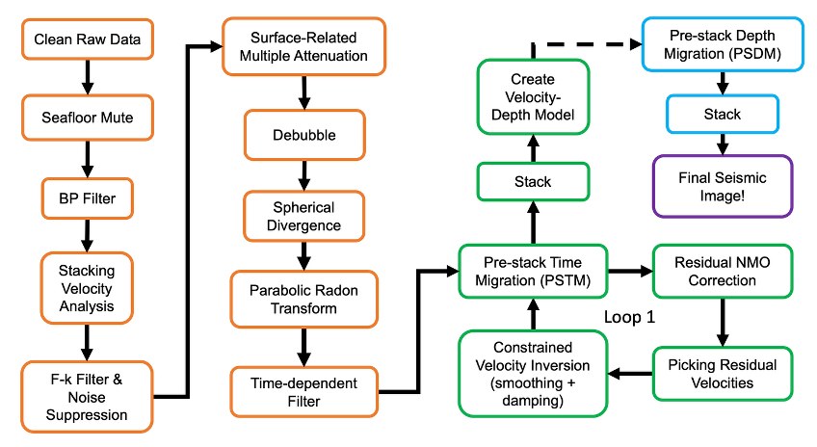
Figure 3. An overview of the methods and techniques used for processing the seismic data.

We used Aspen Paradigm's Echos to produce seismic reflection images from the MCS data (Fig. 3-6). The first step involves data cleaning, where we aim to keep primary reflections from structures (e.g., the plate boundary) but remove unwanted signals such as multiples (reverberations within the water column). We manually edit and remove bad traces from our shot gathers. A bandpass trapezoidal filter was implemented throughout processing to remove low and high-frequency noise where there is limited signal, with cut-off frequencies from 4-5-92-120 Hz. A f-k filter was applied to suppress unwanted diffractions in the shot gathers. A noise frequency band suppression limited noise between 4-12 Hz and was used to suppress high amplitude noise bursts.
To suppress multiples, we performed surface-related multiple attenuation (SRMA). This method required a static shift in sources and receivers—same station location at the free surface—so headers were adjusted. The multiple removal model involved two steps: 1) Surface-Related Multiple Attenuation (SRMA) model that predicts multiples that aim to match the recorded multiples, with respect to TWT, amplitudes, and wavelet shapes. 2) An adaptive subtraction of the multiple model that iteratively matches the different aspects of the multiple’s amplitude and frequency and subtracts it from the data. After SRMA, a debubbling technique was applied to suppress source bubble oscillations and reverberations generated by the airgun array. A spherical divergence correction was implemented to correct for geometric spreading. Additionally, we used parabolic Radon transforms to further remove residual multiples by separating primary reflections and multiples in the velocity domain. A time-dependent filter was applied to contain the high frequencies in shallow subsurface and low frequencies of deep primary reflections.
We use pre-stack time migration to improve our images by repositioning seismic reflections events to their correct locations in the subsurface before stacking. This option allowed us to obtain a more accurate subsurface image and to make structures more clear because it enhances sharp and steeply dipping structures (Dondurur, 2018). A residual velocity analysis is used to refine the velocity model, which involves picking residual velocities and undertaking a constrained velocity inversion to update the velocity model before performing another migration. Then we stacked to enhance the signal-to-noise ratio. Our finalized images used pre-stack depth-migration with an improved velocity model that includes residual NMO refinement and constrained velocity inversion smoothing and damping parameters.

3.3 Reflection Coefficient Estimation
Reflection coefficients for the seafloor (RCsf) and megathrust (RCmt) interface were estimated using amplitudes measured from pre-stack shot gathers. To preserve relative amplitudes for the seafloor and multiples, shot gathers without spherical divergence correction were used to estimate seafloor reflection coefficients (RCsf). Shot gathers with spherical divergence correction were used for megathrust reflection analysis to compensate for geometric spreading losses at greater travel times.
Amplitudes were measured for the seafloor, multiple and megathrust from the five nearest-offset traces for each shot gather and averaged. For each reflector, the maximum peak and adjacent trough amplitudes were identified. Reflection coefficients were estimated using amplitude ratio methods:
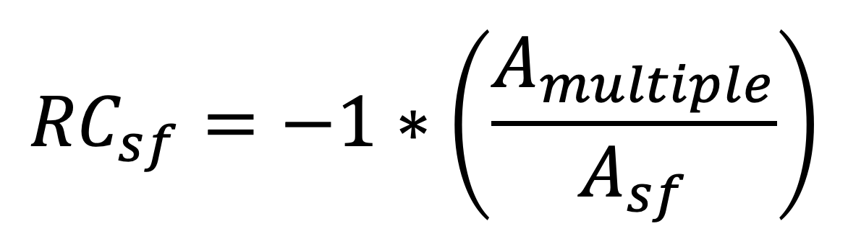
and
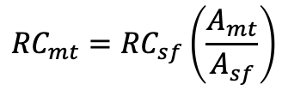
Where $A_{multiple}$, $A_{sf}$, $A_{mt}$ represent measured reflection amplitudes for the seafloor multiple, seafloor reflection, and megathrust reflection, respectively (Warner, 1990).
Reflection coefficients are related to contrasts in acoustic impedance across an interface according to:
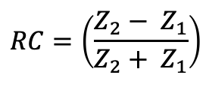
where Z = ⍴Vp, ⍴ is density, and Vp is compressional P-wave velocity. This relationship provides a framework for comparing observed reflection coefficients with theoretical impedance contrasts derived from estimated seismic velocities and densities of prism and oceanic crustal materials.
To compare observed reflection coefficients with theoretical impedance, densities for accretionary prism material were estimated from P-wave velocities using Gardner’s velocity-density relationship (Gardner et al., 1974):
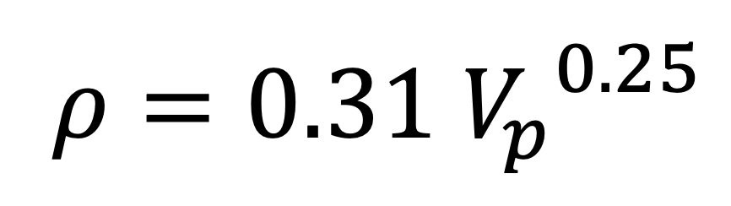
where ⍴ is in g/cm³, and Vp is in m/s. Accretionary prism velocities ranging from (1.8-2.6 km/s) were used for the accretionary prism directly above the megathrust based on stacking velocity analysis. Estimated prism densities were combined with seismic velocities to calculate the expected impedance (Z = ⍴Vp) and theoretical reflection coefficients. Oceanic crust end members included a low-velocity altered upper crust model (Vp = 3.1 km/s, ⍴ = 2.6 g/cm³) and a higher-velocity, more competent upper crust (Vp = 4.5 km/s, ⍴ = 2.7 g/cm³) (Kirkpatrick, 1979; Carlson & Raskin, 1984). These values were then compared with observed reflection coefficients to evaluate plausible lithologic and fluid property contrasts across the plate boundary.
Because reflection polarity of the megathrust was difficult to confidently determine, megathrust amplitudes were measured on both the highest amplitude trough and peak associated with the megathrust. To estimate the reflection coefficient of the seafloor, using the highest amplitude trough of the multiple consistently produced physically reasonable values, whereas using the first trough of the multiple occasionally yielded non-physical reflection coefficients greater than one (Fig. 8). Therefore, the final reflection coefficient estimates were calculated using the trough after the primary reflection peak in the multiple.

4.0 Results
The seismic reflection profiles offshore Guerrero, Mexico presented here reveal several key features of the subduction zone structure and of the subsurface geology that can give context to megathrust earthquakes and slip behavior.

4.1 The Incoming Cocos Plate
Trench-perpendicular Line 3 displays high-amplitude reflections from the sediments on the oceanic Cocos Plate with an average thickness of ~120 m (Figs. 4, 6). These reflections are interpreted to be a pelagic-hemiplagic sediment deposited on the oceanic crust based on nearby ocean drilling (Watkins et al., 1981). Line 3 also highlights several structural features in the oceanic crust, including abyssal hill faults and a prominent seamount. The top of the oceanic crust is generally relatively smooth with gentle undulations draped by sediments. A seamount is present 46 km from the trench and is 8 km wide and approximately 700 m tall. A couple of possible abyssal-hill faults are observed with widths of about ~2 km at 70 km away from the trench, which are interpreted to have formed at the East Pacific Rise. Moho is partially visible ~6 km below the oceanic crust (Fig. 4).
We have identified bending faults on Line 3, where the first bending fault appears ~23 km away from the trench (Fig. 6, 7). Bending faults are recognized by sharp offsets on the youngest sediments, the seafloor, and the basement topography. Measured vertical offsets along the bending faults range from 40-180 m at the seafloor and 40-310 m at basement, with average offsets of ~70 m and ~125 m, respectively (Fig. 7B). Fault spacing is generally ~1.5 km. A mixture of bending fault dips trend seaward and landward, although trenchward-dipping faults are more common.

4.2 Trench & Plate Interface
On Line 3, the Middle America Trench (MAT) is about 5.3 km deep and contains ~200 m of sediment trench fill (Fig. 5). The subduction interface between the Cocos Plate and the North American Plate is shown as a distinct highly reflective boundary at shallow depths (Figs. 4A, 5). A smooth, bright reflection from the plate interface extends 17 km from the trench. However, at distances of >17 km from the trench, the reflection weakens and becomes fainter at depths greater than 8 km. On Line 4, a possible plate interface reflection varies in reflectivity and at depths ~8-12 km below the seafloor (Fig. 4B). It is deeper in the central-northwest compared to the southeast portion of the line.
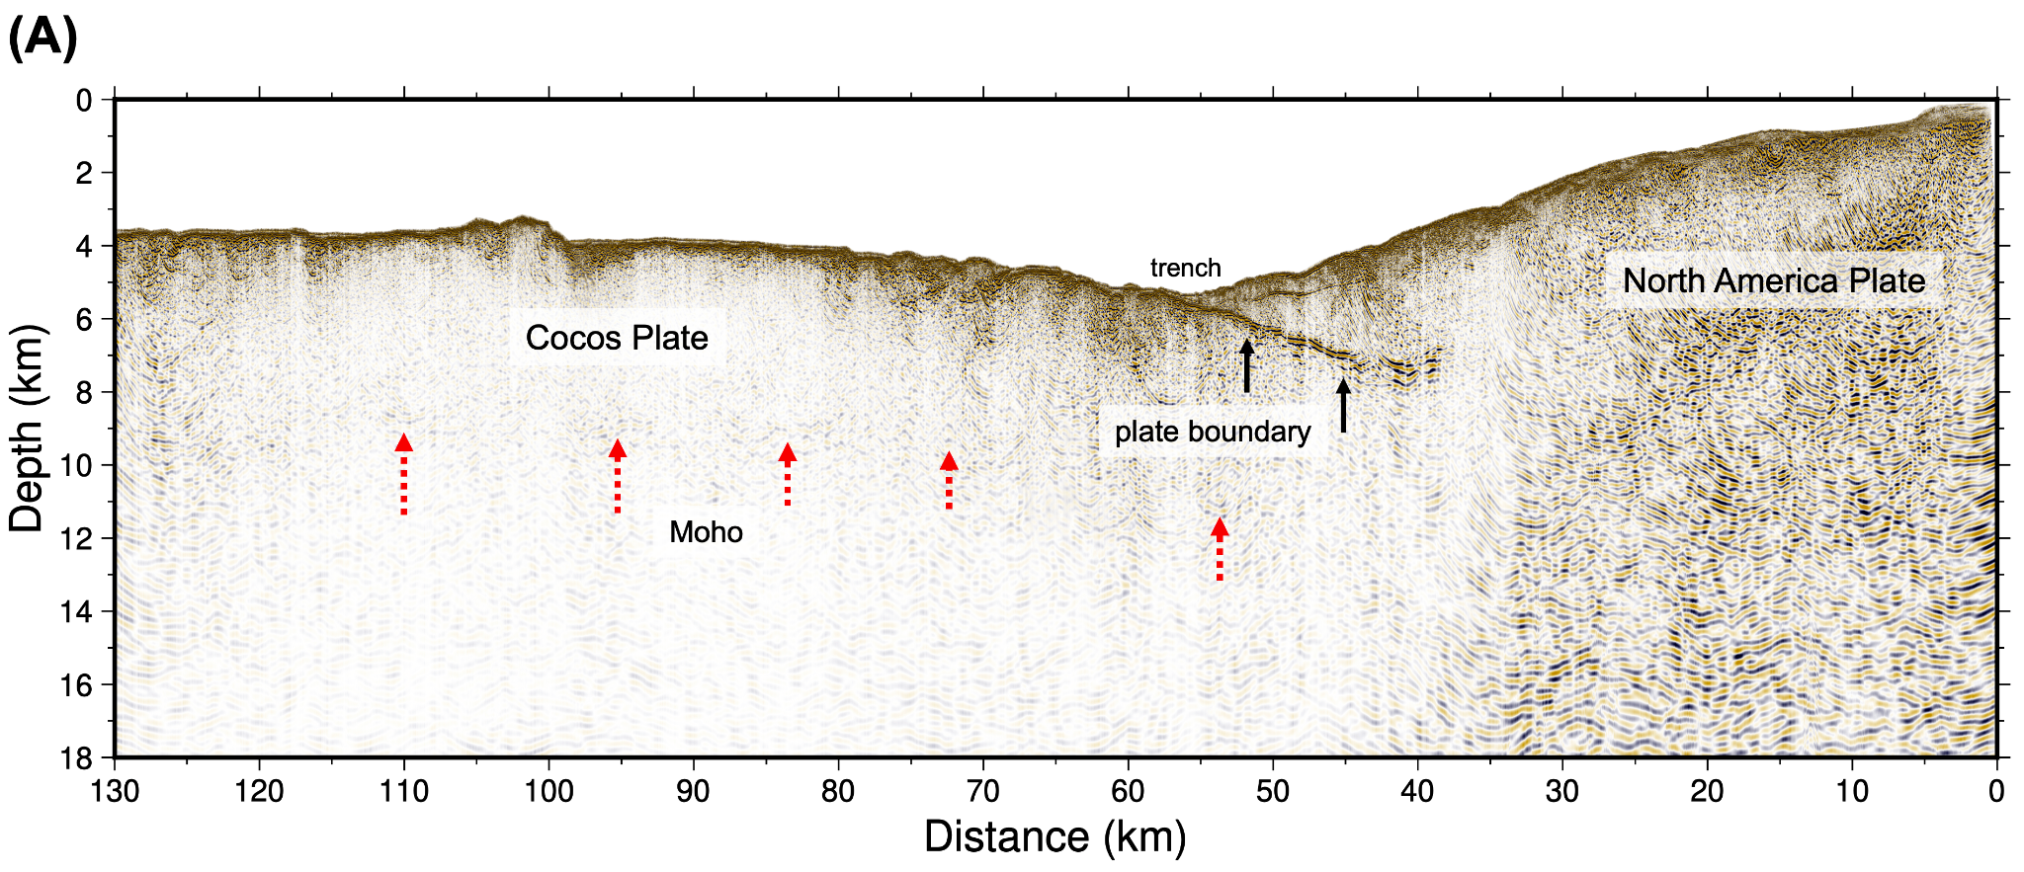
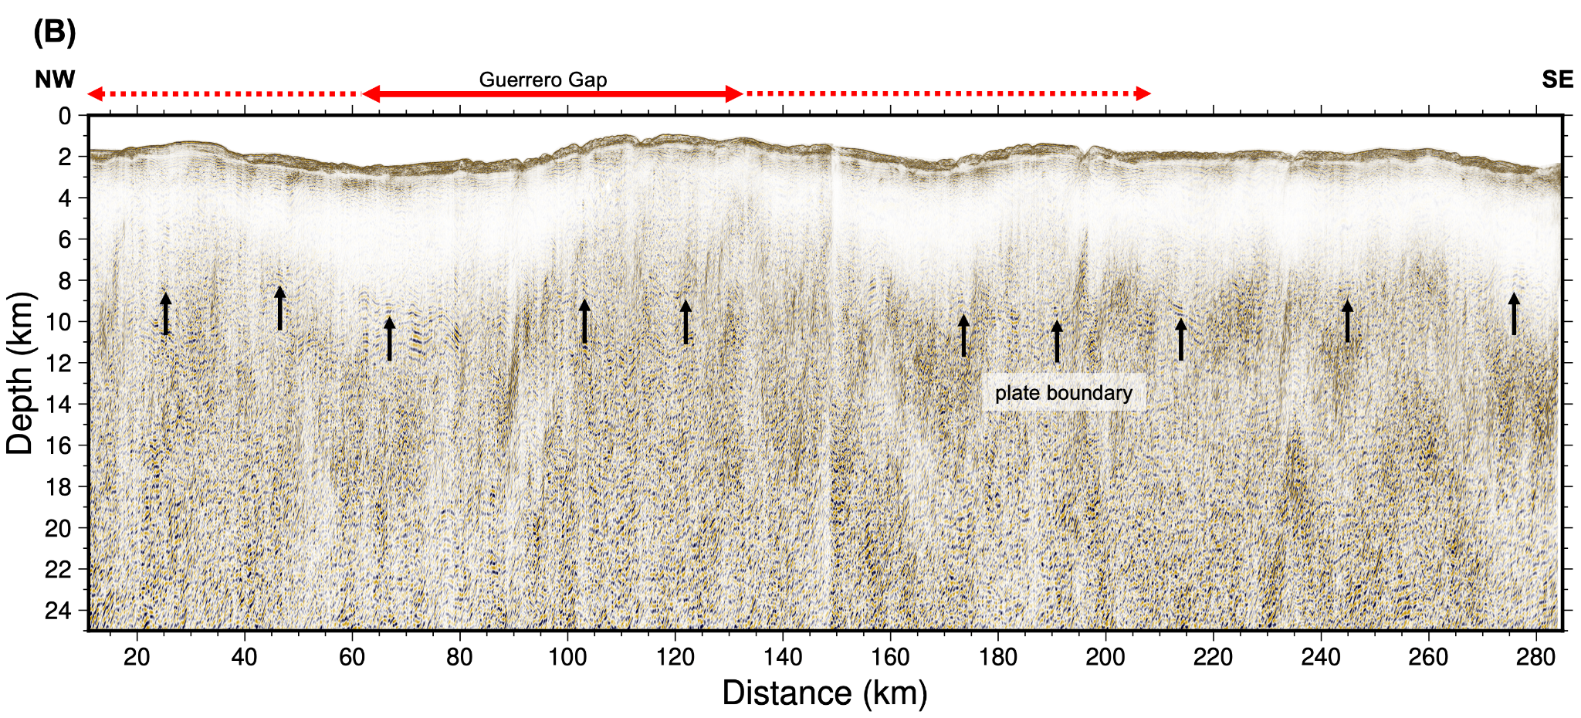
Figure 4. Seismic reflection images of ¡Me Gusta! Experiment. Profiles are labeled on Fig. 2. (A) Line 3 pre-stack depth migration image across the Middle America Trench. (B) Line 4 pre-stack depth migration image along the forearc. The plate boundary is represented with a black arrows. Moho labeled with red dotted arrows. Guerrero Seismic Gap (GSG) is in red, the solid portion is the length in reference to Fig. 2, the dotted line is the downdip an approximate length of the ~200 km from Radiguet et al., (2016).

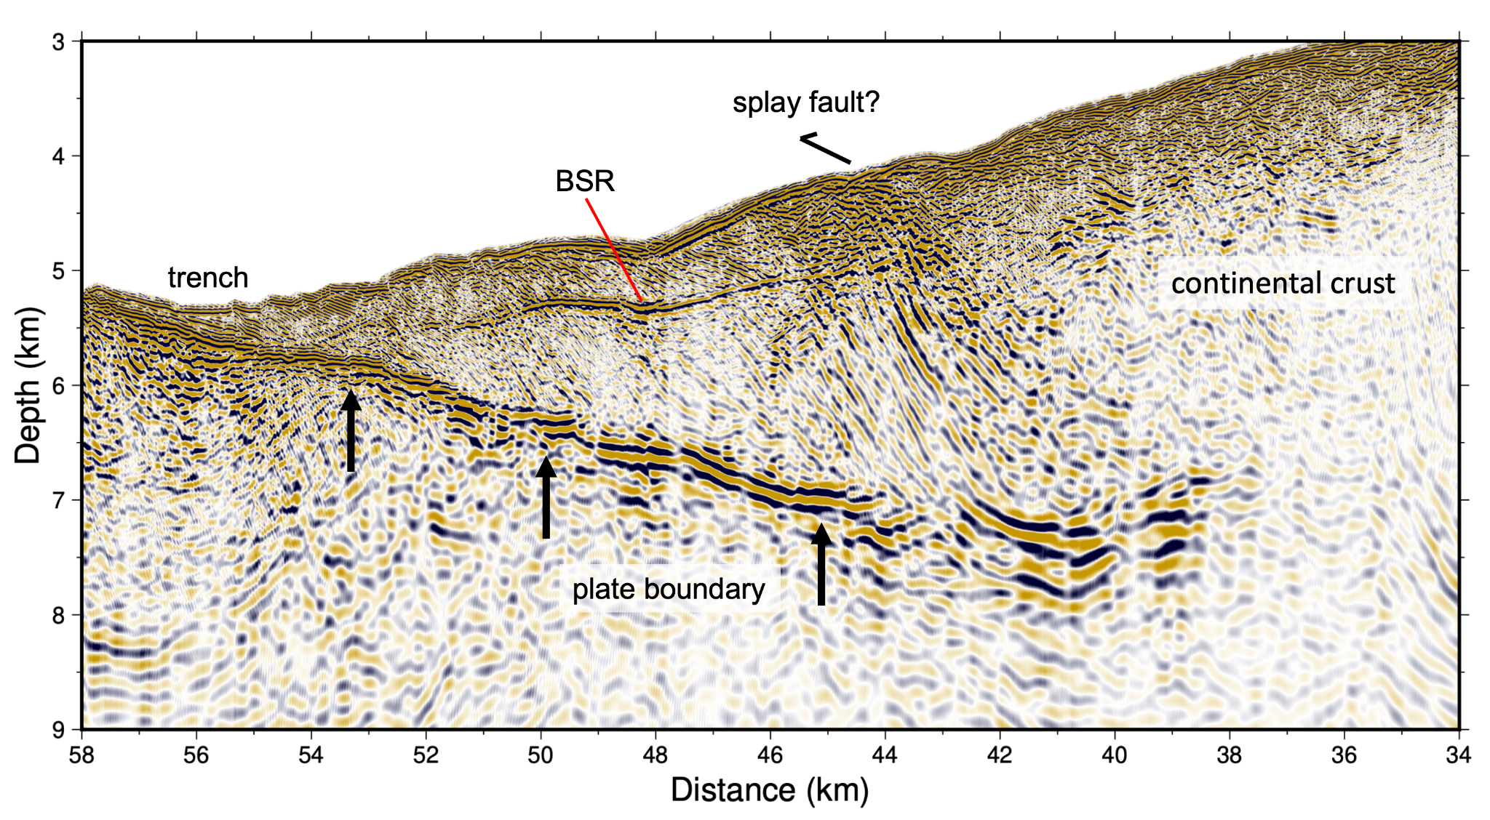
Figure 5. Accretionary prism and trench on Line 3. Black symbol and text represents the interpreted location of a splay fault. Black arrows represent the plate boundary reflection. Bottom-simulating reflector (BSR) is labeled with a red line and text.

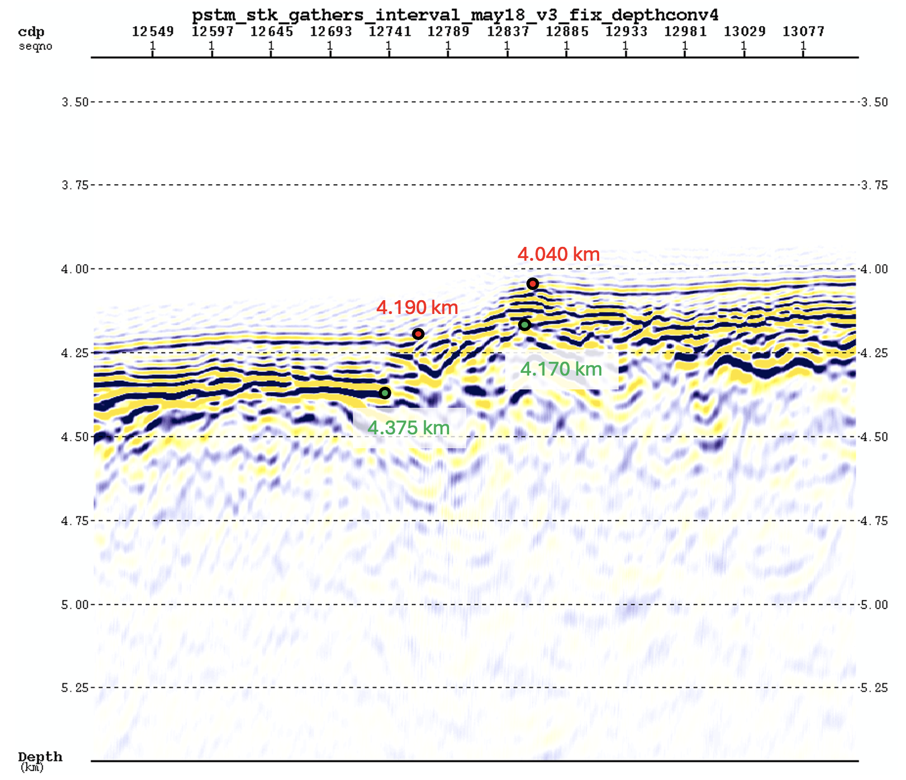
Figure 6. An example of vertical separation measurements across a bending fault on Line 3. Red points mark interpreted seafloor picks and green points mark interpreted basement picks used to quantify displacement. Vertical separation was measured across each fault to assess the extent of deformation within the incoming oceanic plate prior to subduction.

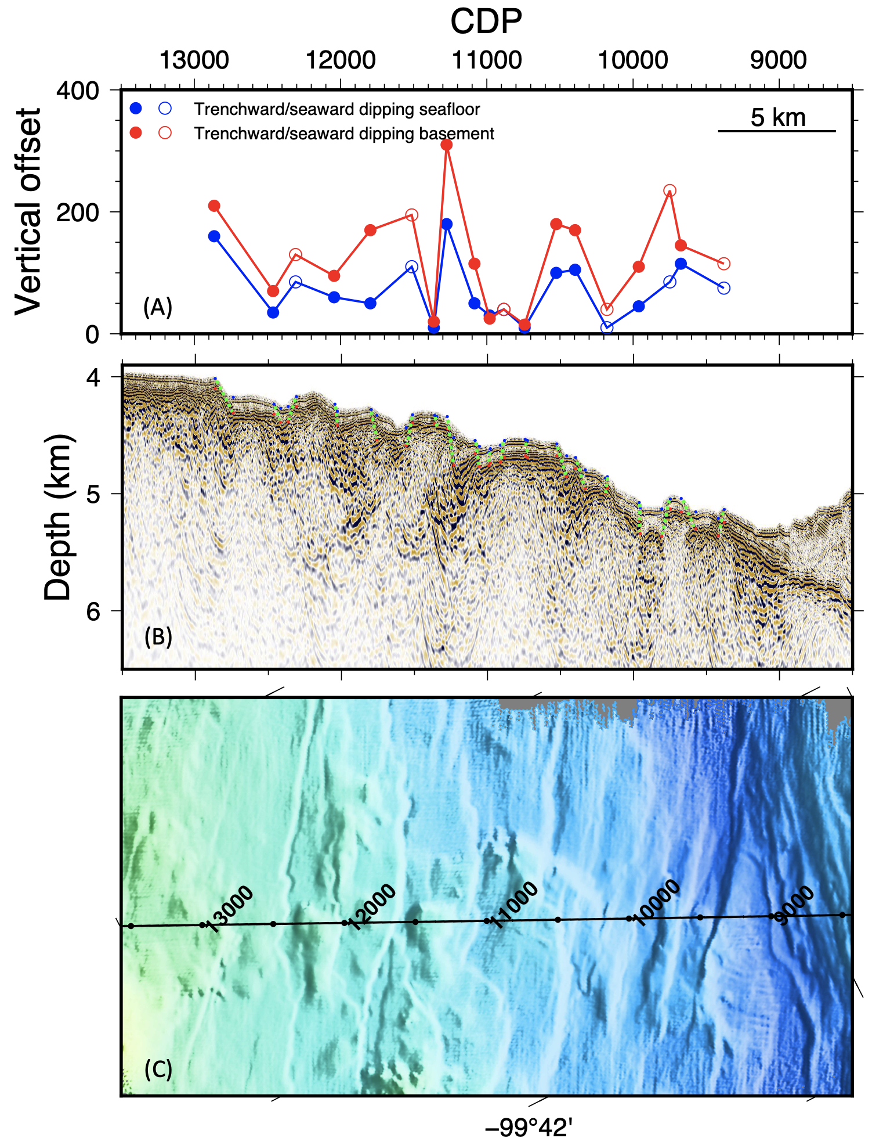
Figure 7. Bending faults on Line 3. (A) Measured vertical offsets at the seafloor (blue) and top of basement (red) on bending faults. (B) MCS data across bending faults interpreted as green dotted lines. Approximate measurement locations at seafloor and basement shown with blue and red dots, respectively. (C) Bathymetry data along Line 3 with CMPs measured for reference.

Reflection coefficients were calculated for both the seafloor and megathrust interface using amplitude ratios derived from pre-stack shot gathers of Line 3 (Fig. 8). Across the analyzed shot gathers (31973–31990), seafloor reflection coefficients (RCsf) range from ~0.13 to 0.34, while megathrust reflection coefficients (RCmt) range from ~0.11 to 0.25 (Fig. 9, 10). These values indicate moderate to strong reflector amplitudes and impedance contrasts at the plate boundary.
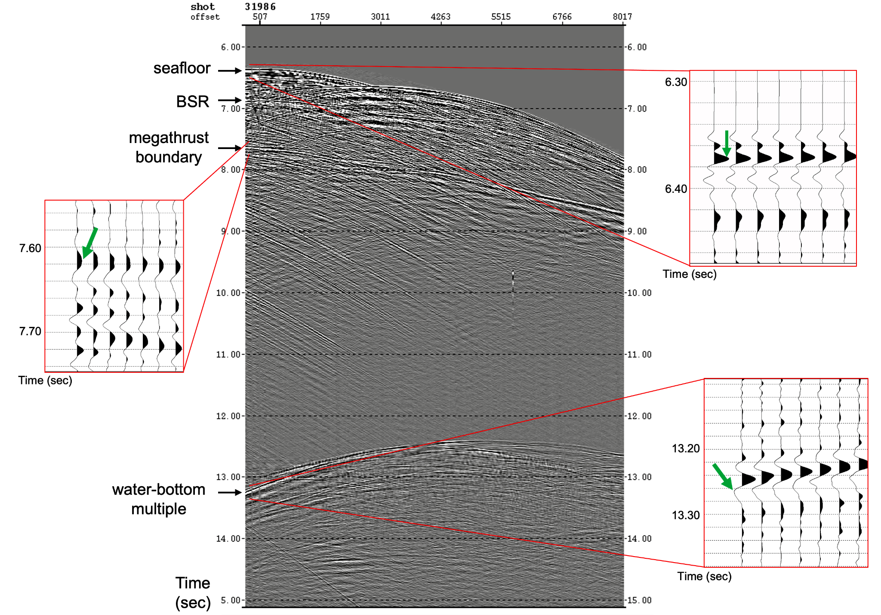
Figure 8. Pre-stack shot gather 31986 used for reflection coefficient analysis. Amplitudes were measured from the five nearest-offset traces for the seafloor reflection, seafloor multiple, and megathrust reflection. Shot gathers without spherical divergence correction were used for seafloor and multiple amplitude measurements, while gathers with spherical divergence correction were used for megathrust amplitude measurements to compensate for geometric spreading effects. Green arrows show where amplitudes were picked on the waveforms. Reflection polarity uncertainty is shown by the presence of both pre-peak and post-peak trough amplitudes associated with the seafloor reflection. Final reflection coefficient estates were calculated using amplitudes from the trough following the primary peak.
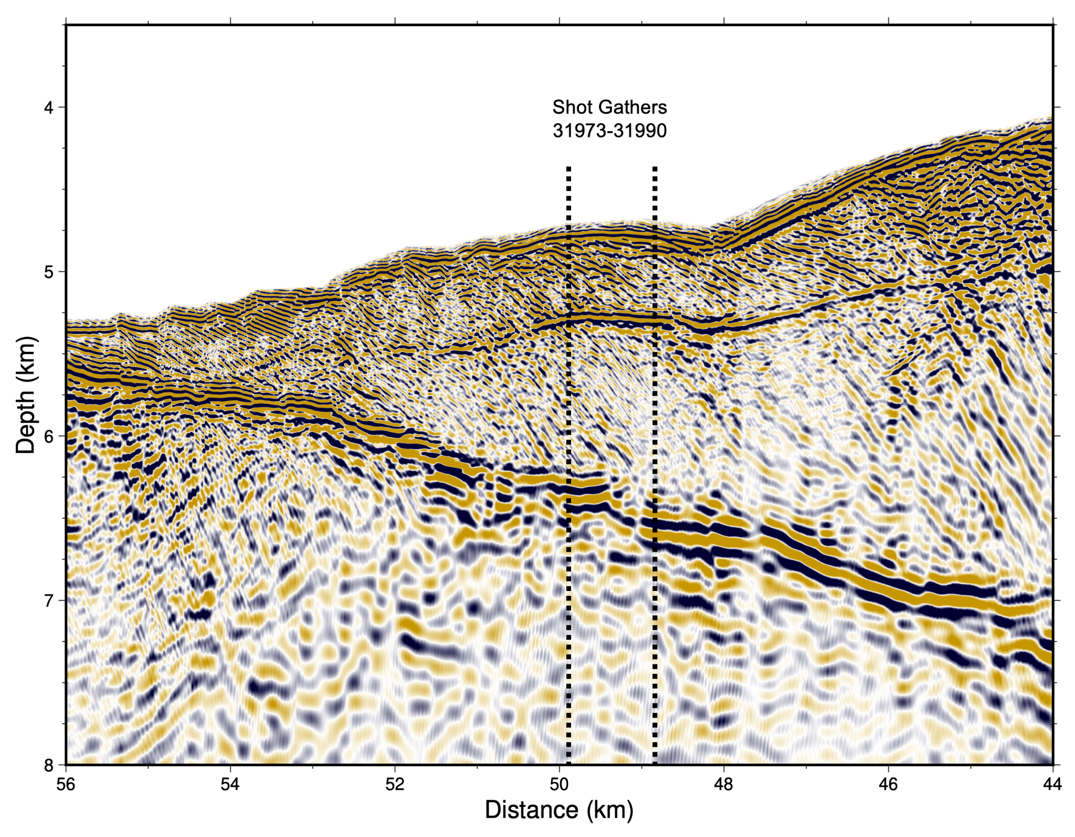
Figure 9. Location of shot gathers used for reflection coefficient analysis on Line 3. Vertical black dotted lines indicate the range of 31973-31990 used. These shot gathers sample the shallow megathrust reflection imaged beneath the accretionary prism.

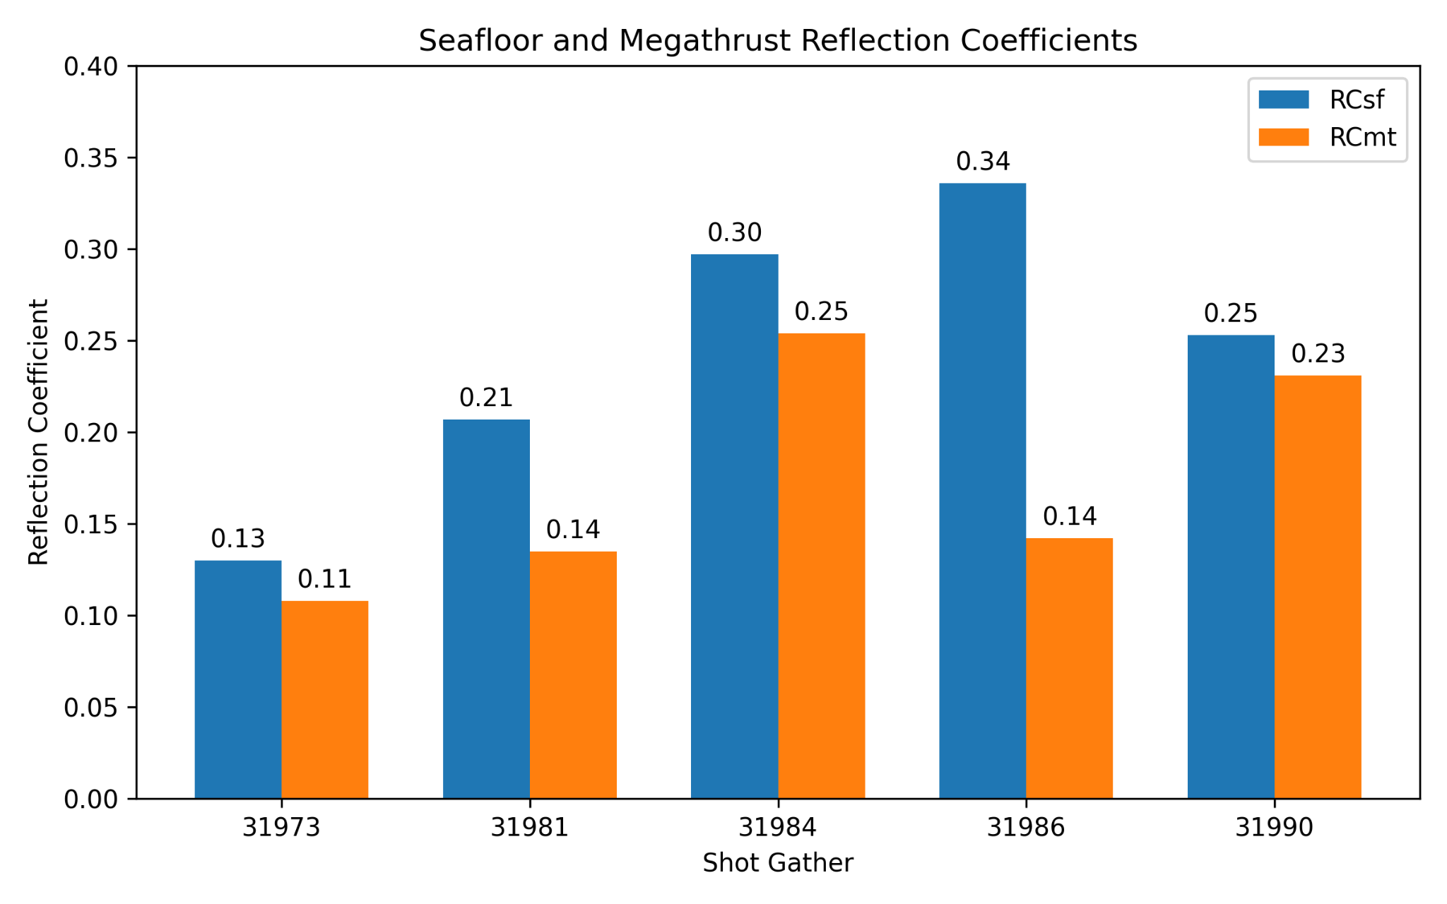
Figure 10. Bar graph showing calculated seafloor reflection coefficients (RCsf) and megathrust reflection coefficients (RCmt) for analyzed shot gathers across the MSZ. Reflection coefficients were estimated from averaged amplitudes measured across the five nearest-offset traces using pre-stack shot gathers. Final values were calculated on the largest amplitude trough to obtain a maximum estimate of megathrust RC.

4.3 Accretionary Prism and Overriding North America Plate
The accretionary prism on Line 3 extends approximately ~13 km landward from the trench (Fig. 5B). This wedge marks the region where sediments and materials from the subducting plate are scraped off and accreted to the overriding plate. We interpret the landward end of the accretionary prism to be bound by a splay fault 11 km away from the trench that reaches the megathrust at a depth of ~4.5 km below the seafloor that we interpret as a backstop. The seafloor dips at 6° NE across the accretionary prism and the plate boundary dips at 8.2º NE, yielding a taper angle of 14.2°. We also observe a bright reflection 500 to 900 m below the seafloor that parallels the seafloor, which we interpret as a bottom simulating reflector marking the phase boundary between methane hydrate and free gas (Haacke et al., 2007). The BSR is disrupted by small-scale thrusts in the frontal prism, shown as a non-continuous reflective boundary.
Along the forearc, Line 4 sediment thickness ranges between 250-500 m. Sediment layers are the thickest in the northwestern portion and thinnest in the southeastern portion. Along the entire segment, there are laterally continuous sediment layers to depths of 100-200 m below the seafloor. However, at depths >200 m below the seafloor, the sediment reflections appear more chaotic and discontinuous. Beneath the sediment, the forearc crust is not very reflective and appears to be seismically transparent.

5.0 Discussion
The seismic reflection profiles from Lines 3 and 4 provide new insights into the plate boundary and overriding plate structure along the Guerrero segment of the Mexico Subduction Zone (MSZ). These data help address key questions about how incoming plate roughness, sediment input, fluid content, and crustal structure influence megathrust properties and behavior, particularly the occurrence of slow slip events (SSEs) and the potential for large earthquakes.

5.1 Influence of the Incoming Plate on Megathrust Properties
The incoming plate’s bending faults and seamounts introduce heterogeneous features that could later play a role in slip behavior. The bending faults are likely to be reactivated abyssal hill fabric. Because this fabric is nearly parallel to the Mexico trench, the likelihood of reactivation is greater due to the pre-existing weak faults with favorable geometries that align with the extension caused by the bending of the subducting plate (Clarke et al., 2024; Billen et al., 2007; Masson 1991). Line 3 crosses a small chain of seamounts on the incoming plate, though it does not image all of the seamounts due to its orientation. Divins (2006) seafloor sediment thickness model and seismic reflection images from the ¡Me Gusta! project (Hagemeier et al., in review) shows sediment thickness is greater to the northwest of the Guerrero Gap than in the area of Line 3. Sediment thicknesses along Line 3 align well with the results from DSDP Leg 66, which documented pelagic to hemipelagic sediments averaging ~110 m in thickness parallel to the trench (Watkins et al., 1981).
No sediment subduction appears to occur; instead most, if not all, sediment on the incoming plate is accreted to a small frontal wedge (Fig. 5A). The sediment accretion has resulted in the development of tilted beds and/or thrusts, which can be observed as landward dipping reflectors (LDRs) in the accretionary prism. These structures within the prism can influence the pathways for fluid escape and near-trench deformations (Saffer & Tobin, 2011), including the interpreted splay fault. The interruption of the BSR by thrusts further supports that these faults may influence the migration of fluids and dehydration processes (Fig. 5).
Despite the bending faults of the incoming Cocos plate and thin sediment cover observed offshore Guerrero, the plate boundary imaged along Line 3 appears very smooth and homogeneous, with little to no disruption from subducting topography, in contrast to the heterogeneous reflectivity observed on other megathrust with rough seafloor and limited sediment subduction (e.g., Bécel et al., 2017). We observe no significant evidence of subducting seamounts, ridges, or horst-and-graben structures that typically generate local deformation or roughness along the megathrust. This apparent homogeneity is striking, especially considering that the outer rise is visibly faulted and has thin sediment cover. A plausible explanation is that the currently subducted portion of the plate differs structurally from the present-day outer rise, due to differences in inherited variations from mid-ocean ridge spreading and faulting patterns. It is also possible that the smoothness may be from a transition in bending behavior as the plate enters subduction, with fault offsets reduced by mechanical “unbending” beneath the forearc (Billen & Hirth, 2007). We find this unlikely to occur at such shallow depths. Finally, subducting topography could have been decapitated by the overlying forearc, but this explanation is also unlikely because the megathrust is already smooth beneath the accretionary prism, that is not expected to be rigid enough to remove incoming fault topography. These observations provide a structural contrast that is not yet fully understood and would need further investigation.

5.2 Downdip and Along-strike Variations in Megathrust Properties
We observe a large transition from high reflectivity to sudden loss in reflectivity along the plate interface, which occurs more than ~18 km landward of the trench and at depths exceeding ~8 km, may be due to changes in the physical and hydrological properties of the megathrust. One possibility is that reflectivity is controlled by contrasts in acoustic impedance across the fault zone; in particular the shift in overlying material from layered sediments to higher velocity crystalline basement would reduce the contrast in velocities with the subducting oceanic plate and thus cause a reduction in interface reflectivity. Alternatively, this transition may indicate a change within the fault zone itself, particularly a reduction in fluid content due to progressive dewatering of the sediments and upper oceanic crust.
This second interpretation is inconsistent with thermal modeling from the Meso-American Subduction Experiment (MASE) (Perry et al., 2016), which demonstrated that hydrothermal circulation within the incoming oceanic crust offshore Guerrero cools the slab prior to subduction. This cooling shifts primary isotherms (e.g., 100–150°C and 350–450°C) landward and enables fluids to be transported deeper into the subduction zone. If the downdip loss of reflectivity corresponded with this deeper dehydration pulse, then the seismic character of the megathrust could be directly linked to the availability of fluids due to dehydration reactions. Instead, major dehydration reactions resulting in fluid loss occur at larger depths and thus cannot directly explain our observations (Fig. 11). However, we cannot rule out the possibility that changes in fluids may contribute to the reflectivity (e.g., due to updip migration of fluids, dewatering due to compaction rather than dehydration, etc). However, for Line 3 (Fig. 4A), the weakening of reflectivity just seaward of the first major splay fault strongly implies that reflection strength may be primarily controlled by the change in materials over the megathrust.
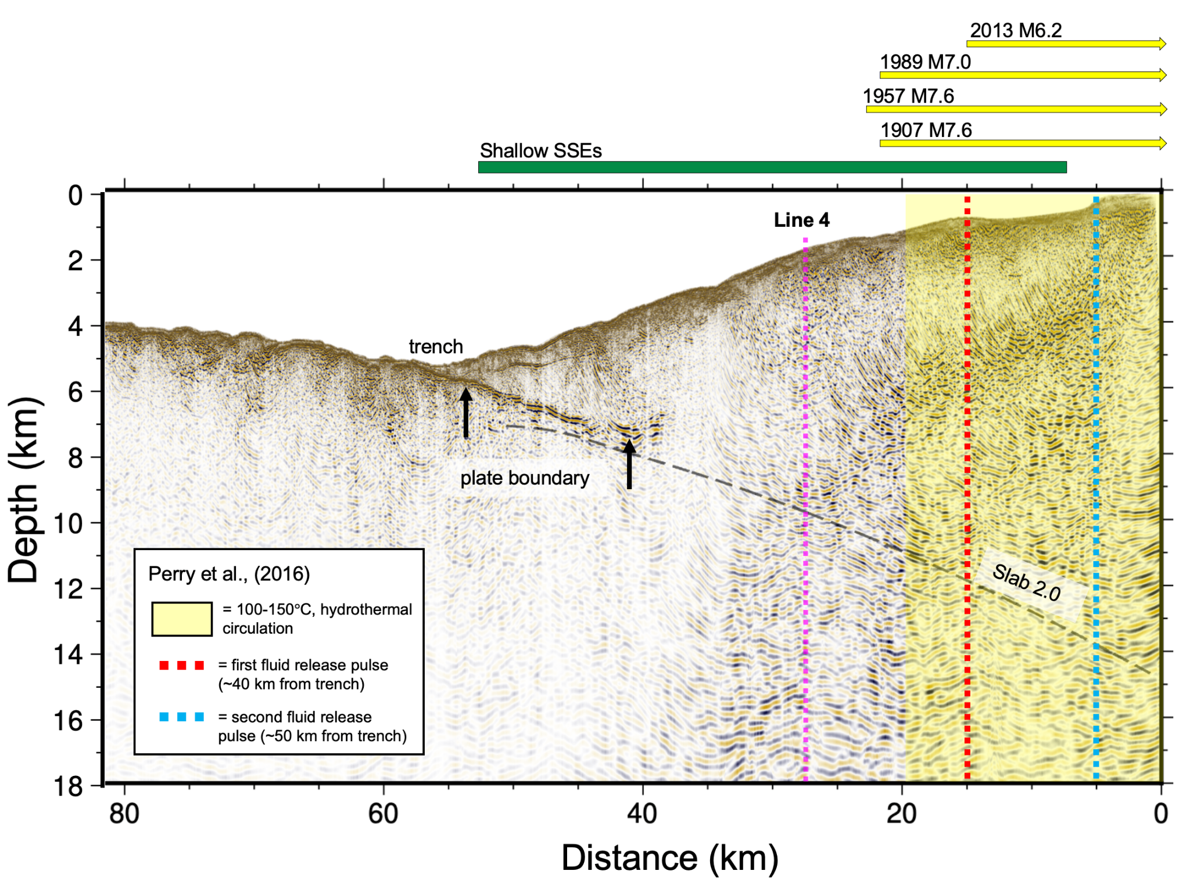
Figure 11. Thermal modeling overlay from Perry et al., (2016). Earthquake rupture extents in yellow arrows and shallow SSEs in green above in reference to Fig. 2. Pink dotted lines indicate the intersection of Line 4. Black arrows represent the plate boundary reflection. Slab 2.0 (Hayes et al., 2018) is labeled with a black dashed line.

The megathrust reflection coefficients provide insight into the physical properties of the plate interface and what accounts for the downdip changes in reflectivity. Reflection coefficients in the range of ~0.1–0.25 suggest a moderate acoustic impedance contrast between the accretionary prism and the subducting oceanic crust. The variability of the RC’s could arise from heterogeneity on the plate boundary or uncertainties in the estimation of the RC’s.
For the former, this variability would likely reflect changes in plate boundary properties such as lithology, sediment thickness, degree of consolidation, and fluid pressure conditions. Such heterogeneity is consistent with the broader interpretation that the megathrust is not a laterally uniform interface, but instead, has spatial variations that may influence coupling and slip behavior. In the context of the MSZ, these variations may be linked to differences in incoming plate structure, sediment input, or fluid migration pathways.
Comparison with theoretical reflection coefficients derived from impedance supports the interpretation that the reflection primarily arises from the contrast between the accretionary prism and the subducting oceanic crust (Fig. 12). The observed RCmt values (~0.11-0.25) are mostly equal to or slightly lower than those predicted for interfaces between accretionary prism and oceanic crust end members. Thus, we can account for even the brightest reflections just with the impedance contrast between the accretionary prism and the oceanic crust. This does not preclude the presence of fluids, but they are not required to explain our observations.
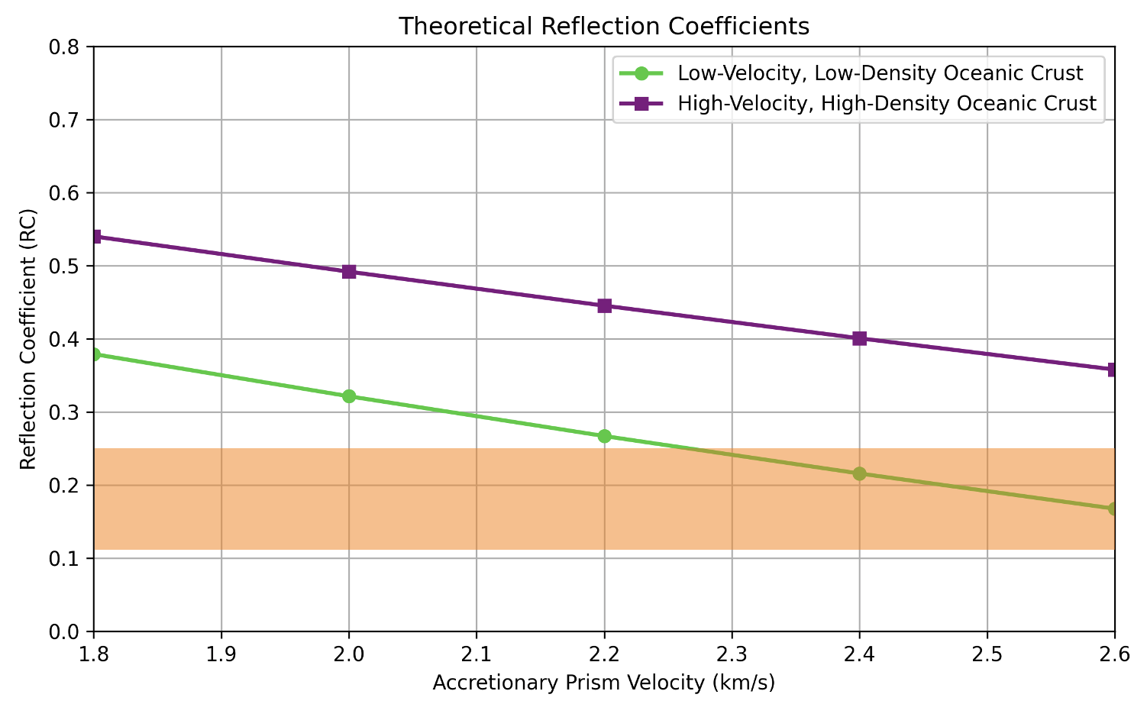
Figure 12. Theoretical reflection coefficients calculated for interfaces between accretionary prism and two oceanic crust end-members. Prism densities were estimated using Gardner’s velocity-density relationship. Reflection coefficients were calculated for prism velocities ranging from 1.8-2.6 km/s using low-velocity, low-density upper oceanic crust (Vp = 3.1 km/s, ⍴ = 2.6 g/cm³, in green) and high-velocity, high-density (Vp = 4.5 km/s, ⍴ = 2.7 g/cm³, in purple) end members (Kirkpatrick, 1979). Our observed RCmt values is highlighted in orange.

An important consideration in the reflection coefficient analysis is the uncertainty associated with reflection polarities and amplitude picking. In several shot gathers, the megathrust can be interpreted as either a trough followed by a peak or a peak followed by a trough, depending on the phase of the seismic wavelet and local interference effects. This ambiguity directly affects the amplitudes used to calculate reflection coefficients. Tests performed using amplitudes from different parts of the waveform provide variable results, including sometimes yielding non-physical reflection coefficients (e.g., RCsf > 1). We chose to interpret parts of the waveform that produce stable and physically reasonable values.
Additional uncertainty with the reflection coefficient analysis may result from local seafloor roughness and topographic variability. The seafloor in the study region is not laterally flat, which can influence reflection amplitudes through variations in incidence angle, focused or defocused seismic energy, and interference from scattered arrivals (Yilmaz, 2001). These effects may contribute to variability in measured amplitudes between adjacent traces and shot gathers. Although averaging amplitudes across five traces reduces some of the variability, seafloor topography remains a potential source of uncertainty in the estimated reflection coefficients. Despite the uncertainties, we think these RC values can still be used for basic tests of controls on reflectivity and suggest that fluids are not required to explain the bright shallow megathrust.

Line 4 provides the opportunity to assess along-strike variations in megathrust reflectivity between the Guerrero Gap and adjacent regions. The northwestern portion of the GSG has brighter reflectivity compared to the rest of Line 4 (e.g., 60-100 km, Fig. 13B). Within the GSG, Line 4 also displays a thicker package of reflectors marking the plate boundary (Fig. 13B). In contrast, the southeastern portion of Line 4, which shows more discontinuous reflectivity, may indicate less coherent plate boundary or reduced fluid content.
The enhanced reflectivity in the Guerrero Gap may partly reflect true plate boundary properties, such as increased fluids, pore-fluid pressure, and/or entrained sediments on this part of the line. Additionally, some of the larger reflector packages observed along Line 4 may correspond to a splay fault that either merges with approaches the main plate interface at the location of Line 4. This interpretation may be supported by observations on Line 3 (Fig. 4). If a splay fault is present, it could play an important role in accommodating strain and influencing fluid pathways, which would further complicate interpretations of the plate boundary reflection on Line 4. Finally, we cannot exclude the possibility that out of plane reflections contribute to the appearance of a broad reflection package. Additional analysis is needed to assess whether portions of the signal are influenced by refractions from multiples contributing to the signal.
The intersection between Lines 3 and 4 provides an opportunity to compare megathrust reflectivity observed in both profiles. At the crossing point, the plate boundary is interpreted at ~8 km depth on both lines, providing independent support for the megathrust. However, reflectivity appears stronger and more laterally continuous on Line 4 than at the corresponding location on Line 3 (Fig. 11 & 13A). This difference may suggest true along-strike variability in plate boundary conditions, differences in imaging geometry between trench-perpendicular and trench-parallel profiles, or from out-of-plane reflections along Line 4. Seismic profiles crossing the MAT from the ¡Me Gusta! Experiment can provide additional support for the presence of a coherent plate boundary reflector in this region.
If enhanced reflectivity in the central to northwestern part of the Guerrero Gap is caused by increased fluids and/or elevated fluid pressures, it could imply a change in the permeability of the overriding plate. Results from offshore of the Mexico subduction zone indicated there is not a large change in subduction zone fluid inputs between the Guerrero Gap and adjacent segments (Acquisto et al., in review), suggesting that a change in drainage may be required to explain changes in fluid on the plate boundary. Husker et al. (2017) proposed that long-lived magmatism beneath the GSG (blue arrows, Fig. 13A) may have resulted in a less permeable, more mafic forearc crust, which could contribute to the trapping of fluids beneath the plate interface and would lead to elevated pore-fluid pressures and promote deep slow slip. These conditions may influence slow slip behavior by weakening the megathrust through fluid overpressure. If gabbroic crust and trapped fluids are also present shallower in the Mexico subduction zone, it could contribute to the observed plate boundary reflectivity on Line 4. Alternatively, the forearc crust in the Mexico subduction zone is built from a complex history (Ferrari et al., 2012), so compositional variations resulting from other parts of this history could cause changes in permeability and fluid accumulation.
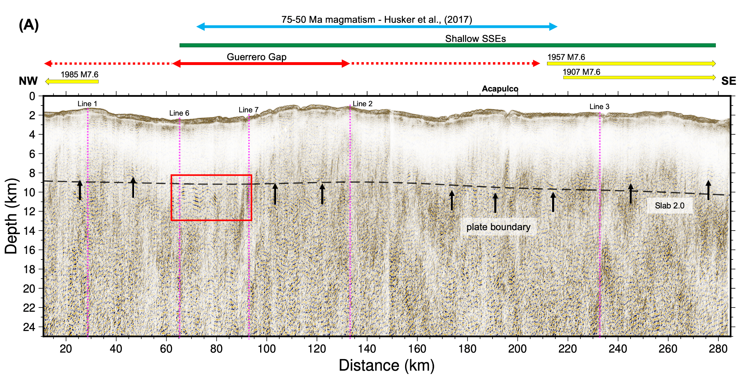

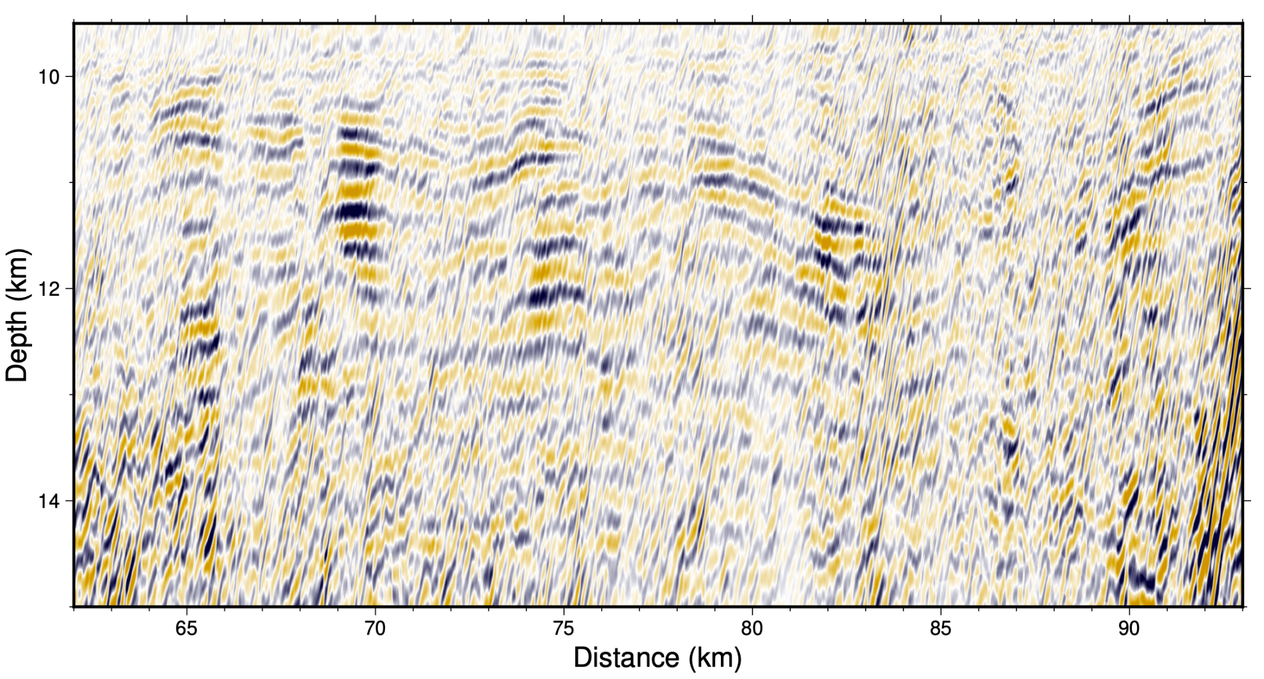
(B)
Figure 13. (A) Overview of Line 4 results. Guerrero Seismic Gap (GSG) is in red, dashed in reference to Radiguet et al. (2012) 200-km-long segment, and bold in reference to Cruz-Atienza et al. (2018) and Fig. 4B. Seismic profile intersections are labeled in pink (Fig. 2). Slab 2.0 is labeled with a black dashed line (Hayes et al., 2018). Earthquake rupture extents are in yellow and shallow SSEs are in green from Fig. 2. The plate boundary is represented with a black arrows. Blue arrows are the extent of Husker et al. (2017) long-lived magmatism. (B) Red box highlights greater reflectivity in the northwest part of the GSG.

5.3 Impacts on Slip Behavior
The seismic characteristics observed along Line 3 and Line 4 provide insights into how variations in plate boundary properties and overriding plate structure may influence slip behavior in the Mexico subduction zone. Specifically, downdip and along-strike transitions in interface reflectivity, the distribution of accreted sediments, and differences in incoming plate roughness could have implications for megathrust coupling and the spatial distribution of slow slip events (SSEs) and earthquakes.
Several historical megathrust ruptures overlap with our seismic profiles, including the 2013 Mw 6.2, 1989 Mw 7.0, 1985 Mw 7.6, 1957 Mw 7.6, and 1907 Mw 7.6 events (Fig. 2). In particular, the landward 25 km of Line 3 crosses a series of historic rupture zones (Fig. 11). Updip, recent seafloor geodesy suggests that shallow slow slip may occur west of the Guerrero Gap and cross with Line 3 (Figs. 2, 11; Cruz-Atienza et al., 2025). Line 4 crosses the Guerrero Gap, where offshore slow slip also occurs, and the rupture zones of large earthquakes flanking it to the west and east (Fig. 11). Here, we compare megathrust properties imaged on these lines with slip behavior.
The smooth and continuous plate interface imaged along Line 3 suggests a relatively homogeneous boundary, with minimal disruption from subducting topography such as seamounts or horst-and-graben structures. A smooth plate interface is often associated with a greater potential for large megathrust earthquakes, as it allows for broader, more continuous rupture propagation with fewer heterogeneities that might otherwise interrupt rupture (Wang & Bilek, 2014; Scholz, 2019). In contrast, zones with rougher subducting features such as seamounts or ridges, are more likely to limit rupture propagation or segment earthquakes due to these structural heterogeneities, potentially reducing earthquake size (Wells et al., 2003; Lay et al., 2012, Takemura et al., 2025). However, megathrust heterogeneity, alone, is unlikely to influence behavior because the megathrust along Line 3 appears to host both seismic rupture at larger depths and slow slip updip (Cruz-Atienza et al., 2025).
On the shallow part of Line 3, where the megathrust is marked by high reflectivity, fluids could be present but they are not required to explain the bright amplitude of this reflection. The lack of subducted trench sediments along Line 3 and the presence of LDRs within the accretionary prism suggest most sediments are being accreted rather than subducted. This structural style is typically associated with fluid expulsion and dewatering, consistent with the observed disruption of the BSR. These features imply that the shallow plate boundary in this region has generally well-drained conditions and limited overpressured fluids, at least at the scale that can be imaged by seismic data. In general, high-permeability pathways created by faulting promote drainage and strengthen coupling, while persistent overpressure that is often associated with sediment subduction, can weaken the shallow interface (Saffer & Bekins, 2006; Bangs et al., 2009). Further downdip, the megathrust is marked by a weak reflection, which implies limited impedance contrasts and fluids. Interestingly, low reflectivity characterizes parts of the megathrust that experience shallow slow slip and earthquake rupture, so plate boundary properties that can be inferred from reflectivity do not appear to differ between the two zones (Fig. 11).
On Line 4, we observe along-strike variations in plate boundary reflectivity, with the brightest reflectivity in the Guerrero Gap where slow slip occurs and weaker reflectivity elsewhere. These brighter reflections could indicate more fluids, pore-fluid pressure, and/or sediment subduction in the Guerrero Gap compared to adjacent areas, which may contribute to the differences in slip behavior here.
Overall, when comparing the extent of ruptures and slow slip to our seismic reflection images, there is not a consistent correspondence between slip behavior and plate interface reflectivity. Some sections of the profiles that intersect past rupture zones appear to have lower reflectivity along the plate boundary and some areas that experience slow slip have bright reflectivity which may arise from fluids, but this pattern is not consistent across our profiles. The lack of a systematic relationship highlights the complexity of megathrust properties and suggests that slip behavior may not be directly predicted from reflection character alone.
At the MSZ, both shallow and deep SSEs have been documented, demonstrating that slow slip can occur across broad portions of the megathrust rather than confined to a single depth range. However, the two types of events differ substantially in magnitude. The recurring deep Guerrero SSEs produce up to ~200 mm of slip and release moment equivalent to Mw 7.5 earthquake (Radiguet et al., 2012; Graham et al., 2017), whereas the shallow SSEs are considerably smaller and spatially more limited (Cruz-Atienza et al., 2025). The occurrence of both deep SSEs and smaller shallow SSEs highlights that slow slip can occur under a range of physical conditions. In many subduction zones, variations of sediment input, fluid pressure, permeability, rigidity, and incoming plate roughness have been proposed as key controls on slip behavior, yet these factors do not show a consistent one-to-one relationship with observed SSEs globally. Overall, the shallow and deep SSEs in Mexico highlights the need to consider combined and spatially variable controls rather than a single dominant mechanism when interpreting megathrust slip behavior.

6.0 Conclusion
This study investigates the physical controls on megathrust behavior along the Guerrero segment of the MSZ. Using MCS data from the 2022 ¡Me Gusta! Experiment, we examined the relationships between incoming plate structure, sediment input, plate interface reflectivity, and overriding plate composition to understand the correlation that produces slow and fast slip.
Our MCS data reveal that the plate boundary offshore Acapulco is remarkably smooth and homogeneous near the trench, lacking topographic disruptions such as seamounts or horst and grabens. This smooth interface—combined with thin trench sediments and limited subduction of sediment—suggests sediment accretion and possibly stronger coupling. However, downdip reflectivity weakens dramatically and crustal structure may indicate the transition from accretionary prism to continental crystalline basement or absence of fluids.
Along-strike comparisons using Line 4 show variations in reflectivity across the GSG, with brighter reflections concentrated in the northwest—potentially associated with the presence of more fluids, enhanced overpressures, and/or more sediment subduction (Husker et al., 2017). These structural and hydrologic conditions align with known zones of SSE activity, but the relationship is not consistent throughout the study area. Our results indicate that plate boundary reflectivity is highly variable along the MSZ and does not show a one-to-one correspondence with either slow slip or earthquake rupture. Reflectivity therefore provides important information about megathrust structure and physical controls but is not, by itself, a reliable predictor of slip behavior.
By integrating seismic reflection imaging with geophysical interpretations and geological context, this work supports that megathrust behavior is controlled by a combination of sediment input, plate interface smoothness, pore-fluid pressures, and crustal heterogeneity. These factors interact to produce a spectrum of slip behavior, from fully locked, earthquake segments to creeping regions dominated by SSEs. These findings from the MSZ contribute to assessing seismic hazards in Mexico and also improve our understanding of how subduction zone structure influences slip behavior.

REFERENCES

Acquisto, T., Bécel, A., Cruz-Atienza, V. M., Shillington, D., Shuck, B., Boston, B., Hagemeier, D., Han, S., Real-Pérez, J., Ward, G., & Ito, Y. (2025). Linking megathrust slip variability to incoming plate hydration in the Guerrero Gap and adjacent segments offshore [Manuscript in review].

Audet, P., Bostock, M. G., Boyarko, D. C., Brudzinski, M. R., & Allen, R. M. (2009). Slab morphology in the Cascadia fore arc and its relation to episodic tremor and slip. Journal of Geophysical Research: Solid Earth, 114(B00B08). https://doi.org/10.1029/2008JB006053

Audet, P., & Bürgmann, R. (2014). Possible control of subduction zone slow-earthquake periodicity by silica enrichment. Nature, 510(7505), 389–392. https://doi.org/10.1038/nature13391

Bangs, N. L., Moore, G. F., Sean, Pangborn, E. M., Tobin, H. J., Kuramoto, S., & Taira, A. (2009). Broad, weak regions of the Nankai Megathrust and implications for shallow coseismic slip. Earth and Planetary Science Letters, 284(1-2), 44–49. https://doi.org/10.1016/j.epsl.2009.04.026

Barnes, P. M., Wallace, L. M., Saffer, D. M., Bell, R. E., Underwood, M. B., Fagereng, A., Meneghini, F., Savage, H. M., Rabinowitz, H. S., Morgan, J. K., Kitajima, H., Kutterolf, S., Hashimoto, Y., Engelmann de Oliveira, C. H., Noda, A., Crundwell, M. P., Shepherd, C. L., Woodhouse, A. D., Harris, R. N., & Wang, M. (2020). Slow slip source characterized by lithological and geometric heterogeneity. Science Advances, 6(13), eaay3314. https://doi.org/10.1126/sciadv.aay3314

Bécel, A., Shillington, D. J., Matthias Delescluse, Nedimović, M. R., Abers, G. A., Saffer, D. M., Webb, S. C., Keranen, K. M., Roche, P., Li, J., & Kuehn, H. (2017). Tsunamigenic structures in a creeping section of the Alaska subduction zone. Nature Geoscience, 10(8), 609–613. https://doi.org/10.1038/ngeo2990

Bécel, A., Shillington, D., Boston, B., Cruz-Atienza, V., & Han, S. (2023). Raw Seismic Navigation Data (P2 format) from the Guerrero Gap, offshore Mexico, acquired during Langseth cruise MGL2204 (2022) [Data set]. Marine Geoscience Data System (MGDS). https://doi.org/10.26022/IEDA/331333

Bedford, J., Faulkner, D. R., Allen, M. J., & Hirose, T. (2021). The stabilizing effect of high pore-fluid pressure along subduction megathrust faults: Evidence from friction experiments on accretionary sediments from the Nankai Trough. Earth and Planetary Science Letters, 567, 117161. https://doi.org/10.1016/j.epsl.2021.117161

Bekaert, D. P. S., Hooper, A., & Wright, T. J. (2015). Reassessing the 2006 Guerrero slow‐slip event, Mexico: Implications for large earthquakes in the Guerrero Gap. Journal of Geophysical Research: Solid Earth, 120(2), 1357-1375. https://doi.org/10.1002/2014JB011557

Bekaert, D. P. S., Hooper, A., & Wright, T. J. (2015). A spatially variable time series from InSAR: Application to the 2006 slow slip event in Guerrero, Mexico. Geophysical Research Letters, 42(3), 923–930. https://doi.org/10.1002/2014JB011558

Beroza, G. C., & Ide, S. (2011). Slow Earthquakes and Nonvolcanic Tremor. Annual Review of Earth and Planetary Sciences, 39(1), 271–296. https://doi.org/10.1146/annurev-earth-040809-152531

Billen, M. I., & Hirth, G. (2007). Rheologic controls on slab dynamics. Geochemistry, Geophysics, Geosystems, 8(8). https://doi.org/10.1029/2007GC001597

Brizzi, S., van Zelst, I., Funiciello, F., Corbi, F., & van Dinther, Y. (2020). How sediment thickness influences subduction dynamics and seismicity. Journal of Geophysical Research: Solid Earth, 125(8), e2019JB018964. https://doi.org/10.1029/2019JB018964

Brudzinski, M. R., & Allen, R. M. (2007). Segmentation in episodic tremor and slip all along Cascadia. Geology, 35(10), 907–910. https://doi.org/10.1130/G23740A.1

Carlson, R. L., & Raskin, G. S. (1984). Density of the ocean crust. Nature, 311(5986), 555–558. https://doi.org/10.1038/311555a0

Černý, J., Ramírez-Herrera, M. T., Garcia, E. S., & Ito, Y. (2020). Seafloor morphology along the active margin in Guerrero, Mexico: Probable earthquake implications. Journal of South American Earth Sciences, 102, 102671. https://doi.org/10.1016/j.jsames.2020.102671

Clarke, J., Shillington, D. J., Regalla, C., Gaherty, J. B., Estep, J., Wiens, D. A., et al. (2024). Controls on bending-related faulting offshore of the Alaska Peninsula. Geochemistry, Geophysics, Geosystems, 25, e2023GC011271. https://doi.org/10.1029/2023GC011271

Cloos, M., & Shreve, R. L. (1996). Shear-zone thickness and the seismicity of Chilean-and Marianas-type subduction zones. Geology, 24(2), 107-110. https://doi.org/10.1130/0091-7613(1996)024<0107:SZTATS>2.3.CO;2

Correa-Mora, F., DeMets, C., Cabral-Cano, E., Marquez-Azua, B., & Diaz-Molina, O. (2008). Interplate coupling and transient slip along the subduction interface beneath Oaxaca, Mexico. Geophysical Journal International, 175(1), 269-290. https://doi.org/10.1111/j.1365-246X.2008.03910.x

Correa‐Mora, F., DeMets, C., Cabral‐Cano, E., Diaz‐Molina, O., & Marquez‐Azua, B. (2009). Transient deformation in southern Mexico in 2006 and 2007: Evidence for distinct deep‐slip patches beneath Guerrero and Oaxaca. Geochemistry, Geophysics, Geosystems, 10(2). https://doi.org/10.1029/2008GC002211

Cruz‐Atienza, V. M., Ito, Y., Kostoglodov, V., Hjörleifsdóttir, V., Iglesias, A., Tago, J., ... & Kido, M. (2018). A seismogeodetic amphibious network in the Guerrero seismic gap, Mexico. Seismological Research Letters, 89(4), 1435-1449. https://doi.org/10.1785/0220170173

Cruz-Atienza, V. M., Tago, J., Villafuerte, C., Wei, M., Garza-Girón, R., Dominguez, L. A., ... & Kazachkina, E. (2021). Short-term interaction between silent and devastating earthquakes in Mexico. Nature communications, 12(1), 2171. https://doi.org/10.1038/s41467-021-22326-6

Cruz-Atienza, V. M., Tago, J., Domínguez, L. A., Vladimir Kostoglodov, Ito, Y., Efraín Ovando-Shelley, Tonatiuh Rodríguez-Nikl, González, R., Franco, S., Darío Solano-Rojas, Beltrán-Gracia, J., Miranda-García, P., Boudin, F., Rivera, L., Bécel, A., Villafuerte, C., Real, J., Ekaterina Kazachkina, & Ronquillo, A. (2025). Seafloor geodesy unveils seismogenesis of large subduction earthquakes in Mexico. Science Advances, 11(37). https://doi.org/10.1126/sciadv.adu8259

Currie, C. A., Hyndman, R. D., Wang, K., & Kostoglodov, V. (2002). Thermal models of the Mexico subduction zone: Implications for the megathrust seismogenic zone. Journal of Geophysical Research: Solid Earth, 107(B12), ETG-15. https://doi.org/10.1029/2001JB000886

Dascher-Cousineau, K., & Bürgmann, R. (2024). Global subduction slow slip events and associated earthquakes. Science Advances, 10. https://doi.org/10.1126/sciadv.ado2191

DeMets, C., Gordon, R. G., & Argus, D. F. (2010). Geologically current plate motions. Geophysical Journal International, 181(1), 1–80. https://doi.org/10.1111/j.1365-246X.2009.04491.x

Dixon, T. H., Jiang, Y., Malservisi, R., McCaffrey, R., Voss, N., Protti, M., & Gonzalez, V. (2014). Earthquake and tsunami forecasts: Relation of slow slip events to subsequent earthquake rupture. Proceedings of the National Academy of Sciences, 111(48), 17039–17044. https://doi.org/10.1073/pnas.1412299111

Ferrari, L., Orozco-Esquivel, T., Manea, V., & Manea, M. (2012). The dynamic history of the Trans-Mexican Volcanic Belt and the Mexico subduction zone. Tectonophysics, 522–523, 122–149. https://doi.org/10.1016/j.tecto.2011.09.018

Frank, W. B. (2016). Slow slip hidden in the noise: The intermittence of tectonic release. Geophysical Research Letters, 43(19). https://doi.org/10.1002/2016gl069537

Gao, H., & Wang, K. (2014). Strength of stick-slip and creeping subduction megathrusts from heat flow observations. Science, 345(6200), 1038–1041. https://doi.org/10.1126/science.1255487

Gaite, B., Iglesias, A., Villaseñor, A., Herraiz, M., & Pacheco, J. F. (2012). Crustal structure of Mexico and surrounding regions from seismic ambient noise tomography. Geophysical Journal International, 188(3), 1413-1424. https://doi.org/10.1111/j.1365-246X.2011.05339.x

Gardner, G.H.F., Gardner, L.W. and Gregory, A.R. (1974) Formation Velocity and Density—The Diagnostic Basics for Stratigraphic Traps. Geophysics, 39, 770-780. https://doi.org/10.1190/1.1440465

Graham, S. E., DeMets, C., Cabral-Cano, E., Kostoglodov, V., Walpersdorf, A., Cotte, N., ... & Salazar-Tlaczani, L. (2014). GPS constraints on the 2011–2012 Oaxaca slow slip event that preceded the 2012 March 20 Ometepec earthquake, southern Mexico. Geophysical Journal International, 197(3), 1593-1607. https://doi.org/10.1093/gji/ggu019

Graham, S., DeMets, C., Cabral-Cano, E., Kostoglodov, V., Rousset, B., Walpersdorf, A., ... & Salazar-Tlaczani, L. (2017). Slow slip history for the Mexico subduction zone: 2005 through 2011. Geodynamics of the Latin American pacific margin, 3445-3465. https://doi.org/10.1007/978-3-319-51529-8_13

Gualandi, A., H. Perfettini, M. Radiguet, Cotte, N., & V. Kostoglodov. (2017). GPS deformation related to the M_{w} 7.3, 2014, Papanoa earthquake (Mexico) reveals the aseismic behavior of the Guerrero seismic gap. Geophysical Research Letters, 44(12), 6039–6047. https://doi.org/10.1002/2017gl072913

Haacke, R., Westbrook, G. K., & Hyndman, R. D. (2007). Gas hydrate, fluid flow and free gas: Formation of the bottom-simulating reflector. Earth and Planetary Science Letters, 261(3-4), 407–420. https://doi.org/10.1016/j.epsl.2007.07.008

Hagemeier, D., Bécel, A., Acquisto, T., Cruz-Atienza, V. M., Shuck, B., & Shillington, D. J. (2026). Characterizing incoming Cocos Plate structure outboard of the Guerrero Gap and adjacent segments offshore Mexico: Implications for along-strike variations in megathrust slip behavior [Manuscript in review].

Hayes, G. P., Moore, G. L., Portner, D. E., Hearne, M., Flamme, H., Furtney, M., & Smoczyk, G. M. (2018). Slab2, a comprehensive subduction zone geometry model. Science, 362(6410), 58–61. https://doi.org/10.1126/science.aat4723

Heuret, A., Conrad, C. P., Funiciello, F., Lallemand, S., & Sandri, L. (2012). Relation between subduction megathrust earthquakes, trench sediment thickness and upper plate strain. Geophysical Research Letters, 39(5), L05304. https://doi.org/10.1029/2011GL050712

Husker, A., Ferrari, L., Arango-Galván, C., Corbo-Camargo, F., & Arzate-Flores, J. A. (2017). A geologic recipe for transient slip within the seismogenic zone: Insight from the Guerrero seismic gap, Mexico. Geology, 46(1), 35-38. https://doi.org/10.1130/G39202.1

Husker, A., Frank, W. B., Gonzalez, G., Avila, L., Kostoglodov, V., & Kazachkina, E. (2019). Characteristic tectonic tremor activity observed over multiple slow slip cycles in the Mexican subduction zone. Journal of Geophysical Research: Solid Earth, 124(1), 599-608. https://doi.org/10.1029/2018JB016517

Hyndman, R. D., Wang, K., Yuan, T., & Spence, G. D. (1993). Tectonic sediment thickening, fluid expulsion, and the thermal regime of the northern Cascadia subduction zone accretionary prism. Journal of Geophysical Research: Solid Earth, 98(B12), 21 865–21 876. https://doi.org/10.1029/93JB02391
Jiang, Y., Liu, Z., Davis, E. E., Schwartz, S. Y., Dixon, T. H., Voss, N., Malservisi, R., & Marino Protti. (2017). Strain release at the trench during shallow slow slip: The example of Nicoya Peninsula, Costa Rica. Geophysical Research Letters, 44(10), 4846–4854. https://doi.org/10.1002/2017gl072803

Kim, Y., Clayton, R. W., & Jackson, J. M. (2010). Geometry and seismic properties of the subducting Cocos plate in central Mexico. Journal of Geophysical Research: Solid Earth, 115(B6). https://doi.org/10.1029/2009JB006942

Kim, Y., Miller, M. S., Pearce, F., & Clayton, R. W. (2012). Seismic imaging of the Cocos plate subduction zone system in central Mexico. Geochemistry, Geophysics, Geosystems, 13(7). https://doi.org/10.1029/2012GC004033
Kirkpatrick, R. J. (1979). The physical state of the oceanic crust: Results of downhole geophysical logging in the Mid-Atlantic Ridge at 23°N. Journal of Geophysical Research: Solid Earth, 84(B1), 178–188. https://doi.org/10.1029/jb084ib01p00178

Kostoglodov, V. (1996). Gravity and seismicity over the Guerrero seismic gap, Mexico. Geophysical Research Letters, 23(23), 3385–3388. https://doi.org/10.1029/96GL03159

Kostoglodov, V., Singh, S. K., Santiago, J. A., Franco, S. I., Larson, K. M., Lowry, A. R., & Bilham, R. (2003). A large silent earthquake in the Guerrero seismic gap, Mexico. Geophysical Research Letters, 30(15). https://doi.org/10.1029/2003GL017219
Lay, T., Kanamori, H., Ammon, C. J., Koper, K. D., Hutko, A. R., Ye, L., Yue, H., & Rushing, T. M. (2012). Depth-varying rupture properties of subduction zone megathrust faults. Journal of Geophysical Research: Solid Earth, 117(B4), n/a-n/a. https://doi.org/10.1029/2011jb009133

Lonsdale, P. Segmentation and disruption of the East Pacific Rise in the mouth of the Gulf of California. Mar Geophys Res 17, 323–359 (1995). https://doi.org/10.1007/BF01227039

Manea, V. C., Manea, M., Kostoglodov, V., Currie, C. A., & Sewell, G. (2004). Thermal structure, coupling and metamorphism in the Mexican subduction zone beneath Guerrero. Geophysical Journal International, 158(2), 775-784. https://doi.org/10.1111/j.1365-246X.2004.02325.x

Masson, D. G. (1991). Fault patterns at outer trench walls. Marine Geophysical Researches, 13(3), 209–225. https://doi.org/10.1007/bf00369150

Maury, J., Ide, S., Cruz‐Atienza, V. M., & Kostoglodov, V. (2018). Spatiotemporal variations in slow earthquakes along the Mexican subduction zone. Journal of Geophysical Research: Solid Earth, 123(2), 1559-1575. https://doi.org/10.1002/2017JB014690

Moore, J. C., Watkins, J. S., McMillen, K. J., Bachman, S. B., Leggett, J. K., Lundberg, N., Shipley, T. H., Stephan, J.-F., Beghtel, F. W., Butt, A., Didyk, B. M., Niitsuma, N., Shephard, L. E., & Stradner, H. (1982). Facies belts of the Middle America Trench and forearc region, southern Mexico: results from Leg 66 DSDP. Geological Society, London, Special Publications, 10(1), 77–94. https://doi.org/10.1144/gsl.sp.1982.010.01.05

Moore, G. F., Taira, A., Bangs, N. L., Kuramoto, S., Gulick, S. P. S., Shipley, T. H., ... & Ike, T. (2001). New insights into deformation and fluid flow processes in the Nankai Trough accretionary prism. Geochemistry, Geophysics, Geosystems, 2(10). https://doi.org/10.1029/2001GC000166

Moore, J. C., & Saffer, D. M. (2001). Updip limit of the seismogenic zone beneath the accretionary prism of southwest Japan: An effect of diagenetic to low-grade metamorphic processes and increasing effective stress. Geology, 29(2), 183–186. https://doi.org/10.1130/0091-7613(2001)029<0183:ULOTSZ>2.0.CO;2
Nishikawa, T., Ide, S., & Nishimura, T. (2023). A review on slow earthquakes in the Japan Trench. Progress in Earth and Planetary Science, 10(1). https://doi.org/10.1186/s40645-022-00528-w

Obara, K., & Kato, A. (2016). Connecting slow earthquakes to huge earthquakes. Science, 353(6296), 253–257. https://doi.org/10.1126/science.aaf1512

Okada, Y., & Nishimura, T. (2023). Systematic Detection of Short‐Term Slow Slip Events in Southcentral Alaska. Geophysical Research Letters, 50(17). https://doi.org/10.1029/2023gl104901

Peacock, S. M., Christensen, N. I., Bostock, M. G., & Audet, P. (2011). High pore pressures and porosity at 35 km depth in the Cascadia subduction zone. Geology, 39(5), 471-474. https://doi.org/10.1130/G31649.1

Perry, M., Spinelli, G. A., Wada, I., & He, J. (2016). Modeled temperatures and fluid source distributions for the Mexican subduction zone: Effects of hydrothermal circulation and implications for plate boundary seismic processes. Geochemistry, Geophysics, Geosystems, 17(2), 550-570. https://doi.org/10.1002/2015GC006148

Perry, M., Muller, C., Marino Protti, Feng, L., & Hill, E. M. (2023). Shallow Slow Slip Events Identified Offshore the Osa Peninsula in Southern Costa Rica From GNSS Time Series. Geophysical Research Letters, 50(20). https://doi.org/10.1029/2023gl104771

Plaza‑Faverola, A., Klaeschen, D., Barnes, P., Pecher, I., Henrys, S., & Mountjoy, J. (2012). Evolution of fluid expulsion and concentrated hydrate zones across the southern Hikurangi subduction margin, New Zealand: An analysis from depth‑migrated seismic data. Geochemistry, Geophysics, Geosystems, 13(8), Q0GC04. https://doi.org/10.1029/2012GC004228
Plaza‑Faverola, A., Henrys, S., Pecher, I., Wallace, L., & Klaeschen, D. (2016). Splay fault branching from the Hikurangi subduction shear zone: Implications for slow slip and fluid flow. Geochemistry, Geophysics, Geosystems, 17, 5009–5023. https://doi.org/10.1002/2016GC006563
Radiguet, M., Kostoglodov, V., Cotton, F., Cotte, N., & Walpersdorf, A. (2012). Slow slip events and strain accumulation in the Guerrero gap, Mexico. Journal of Geophysical Research: Solid Earth, 117(B4). https://doi.org/10.1029/2011JB008801
Radiguet, M., Perfettini, H., Cotte, N., Gualandi, A., Valette, B., Kostoglodov, V., ... & Campillo, M. (2016). Triggering of the 2014 M w 7.3 Papanoa earthquake by a slow slip event in Guerrero, Mexico. Nature Geoscience, 9(11), 829-833. https://doi.org/10.1038/ngeo2817
Ramírez-Herrera, M. T., Lagos, M., Hutchinson, I., Kostoglodov, V., Machain, M. L., Caballero, M., ... & Quintana, P. (2012). Extreme wave deposits on the Pacific coast of Mexico: Tsunamis or storms?—A multi-proxy approach. Geomorphology, 139, 360-371. https://doi.org/10.1016/j.geomorph.2011.11.002
Ruiz, S., Métois, M., Fuenzalida, A., Juan Carlos Ruiz, Leyton, F., Grandin, R., Christophe Vigny, Madariaga, R., & Campos, J. (2014). Intense foreshocks and a slow slip event preceded the 2014 Iquique M _{w} 8.1 earthquake. 345(6201), 1165–1169. https://doi.org/10.1126/science.1256074
Saffer, D. M., & Bekins, B. A. (1998). Episodic fluid flow in the Nankai accretionary complex: Timescale, geochemistry, flow rates, and fluid budget. JGR: Solid Earth, 103(B3), 707–724. https://doi.org/10.1029/98JB01983
Saffer, D. M., & Bekins, B. A. (2006). An evaluation of factors influencing pore pressure in accretionary complexes: Implications for taper angle and wedge mechanics. Journal of Geophysical Research: Solid Earth, 111(B4). https://doi.org/10.1029/2005JB003990
Saffer, D. M., & Tobin, H. J. (2011). Hydrogeology and Mechanics of Subduction Zone Forearcs: Fluid Flow and Pore Pressure. Annual Review of Earth and Planetary Sciences, 39(1), 157–186. https://doi.org/10.1146/annurev-earth-040610-133408
Saffer, D. M., & Wallace, L. M. (2015). The frictional, hydrologic, metamorphic and thermal habitat of shallow slow earthquakes. Nature Geoscience, 8(8), 594–600. https://doi.org/10.1038/ngeo2490
Saux, J. P., Molitors, E. G., Evans, E. L., & Loveless, J. P. (2022). The Role of Slow Slip Events in the Cascadia Subduction Zone Earthquake Cycle. Journal of Geophysical Research: Solid Earth, 127(2). https://doi.org/10.1029/2021jb022425

Scholz, C. H. (2019). The mechanics of earthquakes and faulting. Cambridge University Press.

Schwartz, S. Y., & Rokosky, J. M. (2007). Slow slip events and seismic tremor at circum-Pacific subduction zones. Reviews of Geophysics, 45(3), n/a-n/a. https://doi.org/10.1029/2006rg000208

Shillington, D. J., Bécel, A., Nedimović, M. R., Kuehn, H., Webb, S. C., Abers, G. A., Keranen, K. M., Li, J., Delescluse, M., & Mattei-Salicrup, G. A. (2015). Link between plate fabric, hydration and subduction zone seismicity in Alaska. Nature Geoscience, 8(12), 963–968. https://doi.org/10.1038/ngeo2586
Suárez, G., Monfret, T., Wittlinger, G., & David, C. (1990). Geometry of subduction and depth of the seismogenic zone in the Guerrero gap, Mexico. Nature, 345(6273), 336-338. https://doi.org/10.1038/345336a0
Takemura, S., Yabe, S., Emoto, K., & Baba, S. (2025). Along‐Dip Variations in Source Characteristics of Shallow Slow Earthquakes Controlled by Topography of Subducted Oceanic Plate. Journal of Geophysical Research: Solid Earth, 130(4). https://doi.org/10.1029/2024jb030751

Tilley, H., Moore, G. F., Underwood, M. B., Hernández‐Molina, F. J., Yamashita, M., Kodaira, S., & Nakanishi, A. (2021). Heterogeneous Sediment Input at the Nankai Trough Subduction Zone: Implications for Shallow Slow Earthquake Localization. Geochemistry, Geophysics, Geosystems, 22(10). https://doi.org/10.1029/2021gc009965
Tobin, H. J., & Kinoshita, M. (2006). NanTroSEIZE: The Nankai Trough Seismogenic Zone Experiment. Scientific Drilling, 2, 23–27. https://doi.org/10.5194/sd-2-23-2006
Truttmann, S., T. Poulet, Wallace, L., M. Herwegh, & M. Veveakis. (2024). Slow Slip Events in New Zealand: Irregular, yet Predictable? Geophysical Research Letters, 51(6). https://doi.org/10.1029/2023gl107741

Uchida, N., & Bürgmann, R. (2021). A Decade of Lessons Learned from the 2011 Tohoku‐oki Earthquake. Reviews of Geophysics, 59(2). https://doi.org/10.1029/2020rg000713
von Huene, R., & Scholl, D. W. (1991). Observations at convergent margins concerning sediment subduction, subduction erosion, and the growth of continental crust. Reviews of Geophysics, 29(3), 279–316. https://doi.org/10.1029/91RG00969
Wallace, L. M. (2020). Slow Slip Events in New Zealand. Annual Review of Earth and Planetary Sciences, 48(1), 175–203. https://doi.org/10.1146/annurev-earth-071719-055104
Wang, K., & Bilek, S. L. (2011). Do subducting seamounts generate or stop large earthquakes? Geology, 39(9), 819–822. https://doi.org/10.1130/G31856.1
Wang, K., & Bilek, S. L. (2014). Invited review paper: Fault creep caused by subduction of rough seafloor relief. Tectonophysics, 610, 1–24. https://doi.org/10.1016/j.tecto.2013.11.024 ‌
Warner, M. (1990). Absolute reflection coefficients from deep Seismic reflections. Tectonophysics, 173(1-4), 15–23. https://doi.org/10.1016/0040-1951(90)90199-i
Watkins J. S., Moore J. C., Shipley T. H., Bachman S. B., Beghtel F. W., Butt A., Didyk B. M., Leggett J. K., Lundberg N., McMillen K. J., Niitsuma N., Shepherd L. E., Stephan J. F., Stradner H. (1981). Accretion, Underplating, Subduction and Tectonic Evolution, Middle America Trench, Southern Mexico: Results From DSDP Leg 66. Oceanologica Acta, Special issue, https://archimer.ifremer.fr/doc/00245/35668/
Wells, R. E., Blakely, R. J., Sugiyama, Y., Scholl, D. W., & Dinterman, P. A. (2003). Basin-centered asperities in great subduction zone earthquakes: A link between slip, subsidence, and subduction erosion? Journal of Geophysical Research: Solid Earth, 108(B10). https://doi.org/10.1029/2002jb002072

Yilmaz, Ö. (2001). Seismic Data Analysis: Processing, Inversion, and Interpretation of Seismic Data. Society of Exploration Geophysicists. https://doi.org/10.1190/1.9781560801580

