Additional file 3: Figure S1. Probability of membership (Q) graph from STRUCTURE shown for one example run at K=4. Each individual Rhipicephalus microplus tick (N=1,247) is represented as a vertical bar; the probability of membership to each of four putative genetic groups is given by the scale on the left. Collection labels (Table 1) are provided below each graph panel.

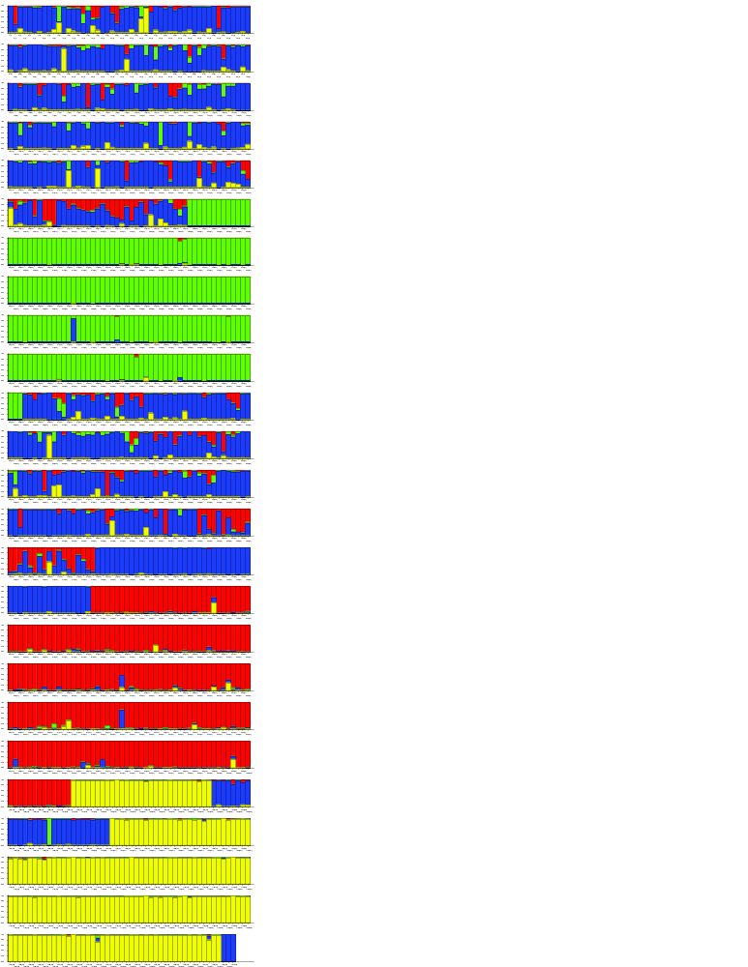
Rm03
23-24
Rm16
Rm20-22
Rm17
Rm23
Rm18-19
Rm13
Rm14
Rm15
Rm16
Rm05
Rm07
Rm06
Rm04
Rm05
Rm02
Rm01

Rm08
Rm27
Rm26
Rm25
Rm13
Rm12
Rm10
Rm11
Rm10
Rm09
Rm43 Madison Co
43 Atascosa
Rm43 source Starr Co

Rm46
Rm45
Rm38
Rm39
Rm41
Rm42
Rm43 Nagocdoches Co
Rm44
Rm42
Rm40
Rm39
Rm35
Rm36
Rm37
Rm36
Rm34
Rm33
Rm32
Rm31
Rm30
Rm30
Rm29
Rm29
Rm28

61-62
Rm60
Rm47
Rm46
55
Rm56
57
Rm52
Rm53
Rm58
Rm59
Rm54
Rm50
Rm51
Rm48
Rm49
Rm50
Rm48
Rm47
Rm47
Rm47
63
Rm59

